**USER MANUAL**



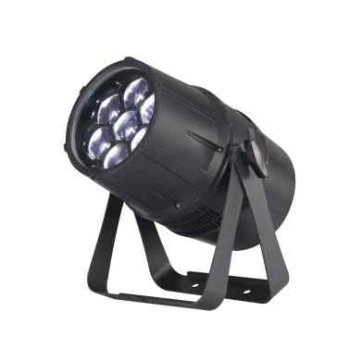

**LED Zoom Cast Aluminum Par Light**

**7X40W RGBW 4in1 LED**

**Part 1 Product**

**1.1 Product introduction**

This product is designed for indoor and outdoor use. Suitable applications include wash or effect lighting for architectural, stage or nightclub applications. This product can also be installed for use in signage and advertising using the dynamic functions available with DMX512 control. Direct input of DMX512 signal allows the units to be controlled from any DMX512 controller. This product can be operated as a single unit or in multiple units for large applications.

**1.2 Technical Specifications**

Voltage: AC100-240V, 50/60Hz

Power: 280W

Light Source:7X40W RGBW 4in1 ultra bright LED

Lifespan: around 50,000-100,000 hours

Control: DMX 7 channels

Control mode: DMX 512, Auto mode, Master/Slave Mode

Display: LED function menu with 4 buttons

Heat dissipation: intelligent temperature control, active

LED life: 50,000-100,000 hours

Beam angle: 5-45 º

**1.3 Safety Warning**

**IMPORTANT:**

|  |
| --- |
| **ALWAYS READ THE USER MANUAL BEFORE OPERATION. PLEASE CONFIRM THAT THE POWER SUPPLY STATED ON THE PRODUCT IS THE SAME AS THE MAINS POWER SUPPLY IN YOUR AREA.** |

This product must be installed by a qualified professional.

● Always operate the equipment as described in the user manual.

A minimum distance of 0.5m must be maintained between the equipment

● The product must always be placed in a well ventilated area.

● and combustible surface.

● Always make sure that the equipment is installed securely.

DO NOT stand close to the equipment and stare directly into the LED light source.

Always disconnect the power supply before attempting and maintenance.

Always make sure that the supporting structure is solid and can support the combined weight of the products.

The earth wire must always be connected to the ground.

Do not touch the power cables if your hands are wet.

**ATTENTION:**

● This product left the place of manufacture in perfect condition. In order to maintain this condition and for safe operation, the user must always follow

● the instructions and safety warnings described in this user manual.

● Avoid shaking or strong impacts to any part of the equipment.

● Make sure that all parts of the equipment are kept clean and free of dust.

Always make sure that the power connections are connected correct and secure.

● If there is any malfunction of the equipment, contact your distributor

● immediately.

When transferring the product, it is advisable to use the original packaging

● in which the product left the factory.

Shields, lenses or ultraviolet screens shall be changed if they have

● become damaged to such an extent that their effectiveness is impaired.

The lamp (LED) shall be changed if it has become damaged or thermally deformed.

**PART 2 INSTALLATION**

**2.1 Mounting:**

**2.1-1 Hanging**

The product can be mounted in a hanging position using the supporting

bracket. The bracket should be secured to the mounting truss or structure using a standard mounting clamp. Please note that when hanging the unit a safety cable should also be used

.

**2.1-2 Upright**

The product can be mounted in an upright or sitting position using the supporting brackets.

**NOTE:**

The product can be mounted at any angle and in any position. It is possible to further adjust the angle of the product using the two adjustment knobs located on the side of the fixture.

**2.2 Special construction for DMX connection.**

☆ At last fixture, the DMX cable has to be terminated with a terminator to

reduce signal errors. Solder a 120-ohm 1/4W resistor between pin 2(DMX-) and pin 3(DMX+) into a 3-pin XLR-plug and plug it in the DMX-output of the last fixture.

☆ If the controller is 5-pin output, it’s necessary to use an adaptor to transfer signal from 5-pin output to 3-pin XLR-plug or you can connect cables as following:

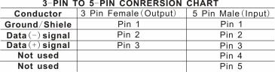

**PART 3 Display Panel Operation**

**3 . 1 Display panel menu instruction**

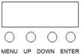

**[MENU]** menu selection or return to previous menu.

**[UP]** press [UP] through the menu list to increase/change the value of the current function.

**[DOWN]** press [DOWN] through the menu list to decrease/change the value of the current function.

**[ENTER]** confirm & quit out current function setting.

**3.2 Display panel operation instruction**

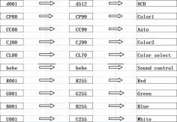

**3.3 DMX Channel instruction**

**8 Channels Mode**

|  |  |  |  |
| --- | --- | --- | --- |
| Channel | Value | Function | Description |
| 1 | 0-255 | 0~ 100% | Dimmer |
| 2 | 0-255 | 0~ 100% | Red |
| 3 | 0-255 | 0~ 100% | Green |
| 4 | 0-255 | 0~ 100% | Blue |
| 5 | 0-255 | 0~ 100% | White |
| 6 | 10-255 | 0~ 100% | Strobe |
| 7 | 0-255 | 0~ 100% | Zomm |

**Part 4, Maintenance**

The cleaning of internal must be carried out periodically to optimize light

output. Cleaning frequency depends on the environment in which the fixture

operates: damp, smoky or particularly dirty surrounding can cause greater

cumulation of dirt on the fixture’s optics.

● Clean with soft cloth using normal glass cleaning fluid.

● Clean the external optics at least every 20 days.

● Always dry the parts carefully.

Clean the internal optics at least every 30/60 days – Up to vary products.

Please ask professional technical to clean waterproof products and make

sure the fixture will be reassembled well for waterproof.