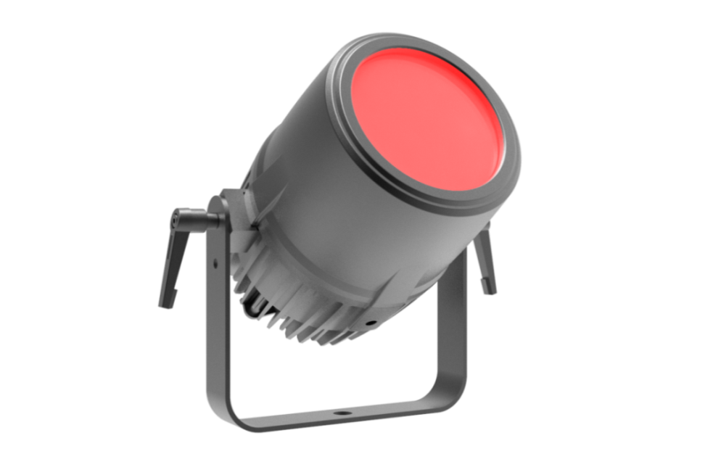

ROUND ZOOM WASH LIGHT
PL-X8

Note: This manual contains important information on how to install and use safely, please read it carefully and install and operate as required, and please keep this manual properly in case you need it.

Content

Safety instructions | 3
Fixture structure and Installation | 4
DMX signal connection and description | 5
DMX address code device, power connection | 6
Control panel | 7
Menu | 8
DMX Channel | 9
Maintenance,troubleshooting | 11
Technical parameters | 12
Dimension | 13

Every unit is tested completely and packed properly by the manufacturer. Please make sure the packing and / or the unit are in good condition before installation and use. Should there be any damage caused by transportation, consult your dealer and do not use the unit. Any damage caused by improper use will not be assumed by the manufacturer and / or dealer.
Please note that as part of our ongoing commitment to continuous product development, specifications are subject to change without notice.

Safety Instructions


The products are packaged in good condition, please follow the user manual,
Machine failure caused by human causes is not covered by the warranty.
Warning

● When unpacking and before disposing of the carton check there is no transportation damage before using the light. Should there be any damage caused by transportation, consult your dealer and do not use the apparatus.

The projector is for indoor and outdoor use, IP65.
Do not install the fixtures onto inflammable surfaces directly.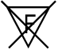

The fixture is only intended for installation, operation and maintenance by qualified personnel.

Do not project the beam onto inflammable surfaces, minimum distance is 3meter. 3m

Avoid direct exposure to the light from the lamp. The light is harmful to the eye.

Do not attempt to dismantle and/or modify the projector in any way.

Electrical connection must only be carried out by qualified personnel.

Before installation, ensure that the voltage and frequency of power supply match the power requirements of the fixture.

It is essential that each projector is correctly earthed and that electrical installation conforms to all relevant standards.

Do not connect this device to any other types of dimmer apparatus.

The projector should always be installed with a secondary safety fixing. A safety cord is supplied for this; it should be attached as
shown in “installing the projector” section.

Shields and lens shall be changed if they have become visibly damaged to such an extent than their effectiveness is impaired, for
example by cracks or deep scratches.

Exterior surface temperatures of the luminaire after 5 minutes operation is 45℃, when steady state is achieved 70℃
There is no user serviceable parts inside the projector, do not open the housing and never operate the fixture with the covers
removed.

If you have any questions, don’t hesitate to consult your dealer or manufacturer.

Fixture structure and installation

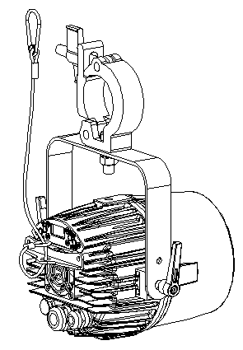

DMX signal connection and description

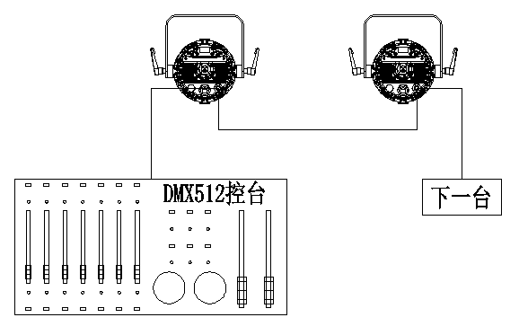

DMX Connection Instruction

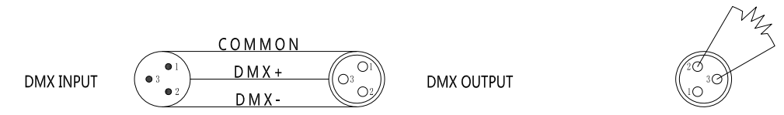

● In order to reduce signal errors and avoid signal weakening and interference during transmission,

A 120 ohm 1/4W resistor can be added between the 2 and 3 cores of the DMX output of the last machine.

● Connect the lamp with XLR signal cable, and connect one end to the output port of the lamp,

The other end is connected to the input port of the next fixture. Signal lines can only be used in series, not in parallel.

Because DMX512 signal transmission speed is very fast, when the signal line is damaged, the welding place is not firm, the contact is not good, etc.

will affect the signal transmission, causing the system to shut down.

● When the machine power supply of a unit is broken, the connection between DMX output and input is bypassed.

In order to maintain the connectivity of the DMX line.

● Each lamp must have an address code that can receive information from the console.

● The terminal of the DMX512 system needs to be equipped with a terminator to reduce signal transmission errors.

DMX Address Code Device

Channel | address | First address | Second address | Third address | Fourth address
7CH | 001-007 | 001 | 008 | 015 | 022
8CH | 001-008 | 001 | 009 | 017 | 025
10CH | 001-010 | 001 | 011 | 021 | 031
(refer to the picture above) the number of lamps added after the fourth set; The address code is based on the channel, and the order is pushed

Power Connection

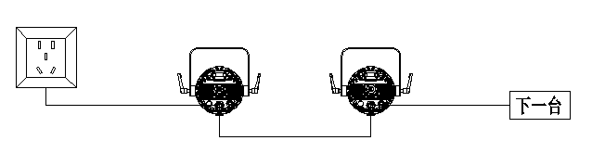

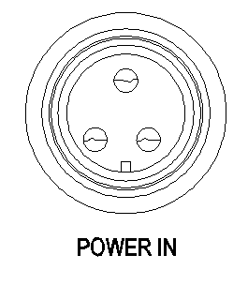
Use of this product power in
Connect the power cable
Note: Use a 1.5 square power cord


A single power cord should never be connected to too many lamps or overloaded.
Do not use power cords that have been damaged by the insulation and do not tie the power cord to other wires.
When the lamp is not in use or clean, unplug the power cord.
Do not unplug or drag the power cord vigorously.
Warning

Control Panel

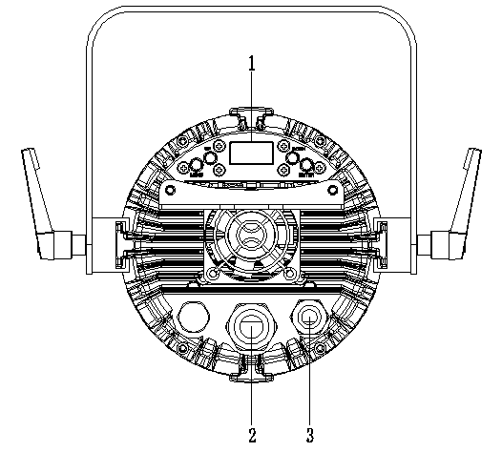

- Panel operation buttons：MEUN、UP、DOWN、ENTER

- Power input and output： POWER IN/OUT Input voltage：100-240V 50/60HZ

- DMX input and output：3-Pin XLR IN/OUT for DMX

Menu

Level 1 | Level 2 | Level 3
1.DMX address | 1-512
 | cancel
 | enter
2.DMX channel mode | 7 channels mode
 | 8 channels mode
 | 10 channels mode
3.Manual selection | zoom
 | red
 | green
 | blue
 | White
4.operation mode | voice
 | Pulse change
 | Gradual change
 | jump
5.Display backlight | On
 | Off
6.temperature | XX℃
7.DMX disconnect | Turn off
 | Maintain DMX status
8.Dimming curve | Linear
 | S curve
 | derivative
 | logarithm
9.Factory reset | No
 | Yes
10.Secondary mode | host
 | DMX mode
 | single

Remark:
1. Only one machine can be set as the host in the same signal line, please remove the DMX control signal when using the host function
2. The parameters that can be transmitted from the host when multiple lamps are synchronously controlled include: DMX channel mode, display setting status, operation mode status (including user program data), when transferring parameters, please set the machine as the host, and other machines as slaves

DMX Channel
7 Channel
Channel mode | Function | DMX value | DMX channel value
1 | Zoom | 0-255 | 0-100%
2 | Strobe | 0-7 | 0-2.7% | Light up
2 | Strobe | 8-255 | 3.1-100% | Strobe speed
3 | Dimmer | 0-255 | 0-100%
4 | Red | 0-255 | 0-100%
5 | Green | 0-255 | 0-100%
6 | Blue | 0-255 | 0-100%
7 | White | 0-255 | 0-100%

8 Channel
Channel mode | Function | DMX Value | DMX channel value
1 | zoom | 0-255 | 0-100%
2 | strobe | 0-7 | 0-2.7% | Light up
2 | strobe | 8-255 | 3.1-100% | Strobe speed
3 | Dimmer | 0-255 | 0-100%
4 | CTC | 0 | 0
4 | CTC | 1-255 | 0.4-100％
5 | Red | 0-255 | 0-100%
6 | Green | 0-255 | 0-100%
7 | Blue | 0-255 | 0-100%
8 | White | 0-255 | 0-100%

10 Channel
Channel | Function | DMX Value | DMX channel value
1 | Zoom | 0-255 | 0-100%
2 | Strobe | 0-7 | 0-2.7% | Light up
2 | Strobe | 8-255 | 3.1-100% | Strobe speed
3 | Dimmer | 0-255 | 0-100%
4 | CTC | 0 | 0
4 | CTC | 1-255 | 0.4-100％
5 | Red | 0-255 | 0-100%
6 | Green | 0-255 | 0-100%
7 | Blue | 0-255 | 0-100%
8 | White | 0-255 | 0-100%
9 | Function selection | 0-50 | No function
9 | Function selection | 51-100 | Jump
9 | Function selection | 101-150 | Gradual change
9 | Function selection | 151-200 | Pulse change
9 | Function selection | 201-255 | voice
10 | Speed | 0-255 | 0-100%

Channel priority: dimming > built-in program call> user program call>ARGBW dimming>HSV dimming > macro > color temperature

Maintenance

In order to extend the service life of lamps, the maintenance of lamps is very necessary. The outdoor use environment is relatively harsh, or the lamp will be placed for a long time

Water vapor and dust accumulate in the lens cover, lamp shell and other components, and the lamp needs to be cleaned to optimize the light efficiency output, while also preventing dust and acidity

Gas causes corrosion to the housing.

The number of cleaning times depends on the frequency of operation of the luminaire and the surrounding environment. Careful wiping with a soft cloth and general glass cleaning products when cleaning is recommended

Clean at least every 20 days.

Do not wipe the lamp housing with organic solvents such as alcohol to avoid damage.

Troubleshooting

Fault description | Solution
The lamp does not start properly | - The power cord is not connected properly  - The switching power supply is damaged or the connection is not normal, and professional qualified maintenance personnel are required for maintenance  - The control board is not connected normally, and professional qualified maintenance personnel are required to overhaul
The light starts, but the LED is not lit and uncontrolled | - The LED mounting plate is not connected normally and needs to be overhauled by professional qualified maintenance personnel
The fixture lights normally, but is not controlled by the controller | - Check whether the DMX start address of the fixture is set correctly  - Check the XLR signal cable for damage
The light is dim and the brightness drops significantly | - The ambient temperature is too high to cause the lamp to overheat, please take necessary ventilation and heat dissipation measures

Technical parameters

Technical data sheet:
Optical parameters
Light source | 60W RGBW LED
Output | 1200Lm
Color temperature | 2000K～10000K
CRI
Beam angle | 3°～35°
Flooding angle
Dynamic effects
Vertical scan | Manual rotation 180°
Color system | RGBW color mixing
Pixel matrix | Overall control
Strobe | 0～20Hz
Dimmer | 4 dimming curves，0～100% dimming
Power parameters
voltage | 100～240VAC , 50～60Hz
Power connection | IP65 Power IN/OUT,maximum connection 6pcs @230V
Data connection | IP65 3-Pin XLR IN/OUT for DMX, maximum number of connections is 32 sets
Power | 60W@230V
Power factor | 0.95/230V
Ambient | -20～45℃
Structural parameters
Dimension | Size:239×203×195 mm； packing size：344*278*270mm
Weight | N.W：2.4kg； G.W：3.4kg
IP rating | IP65
Heat dissipation system | Speed fan heat dissipation
Shell | Die-cast magnesium aluminum alloy, black (can be customized color.)
Installation method | vertical hanging, side hanging
Control
Control method | DMX512
DMX Channel | 7CH/8CH/10CH
Display | The TFT display comes with four touch buttons
Refresh rate | Max 10KHz
Accessory
standard | Power Line 1PCS；Manual 1PCS
option

Dimension

