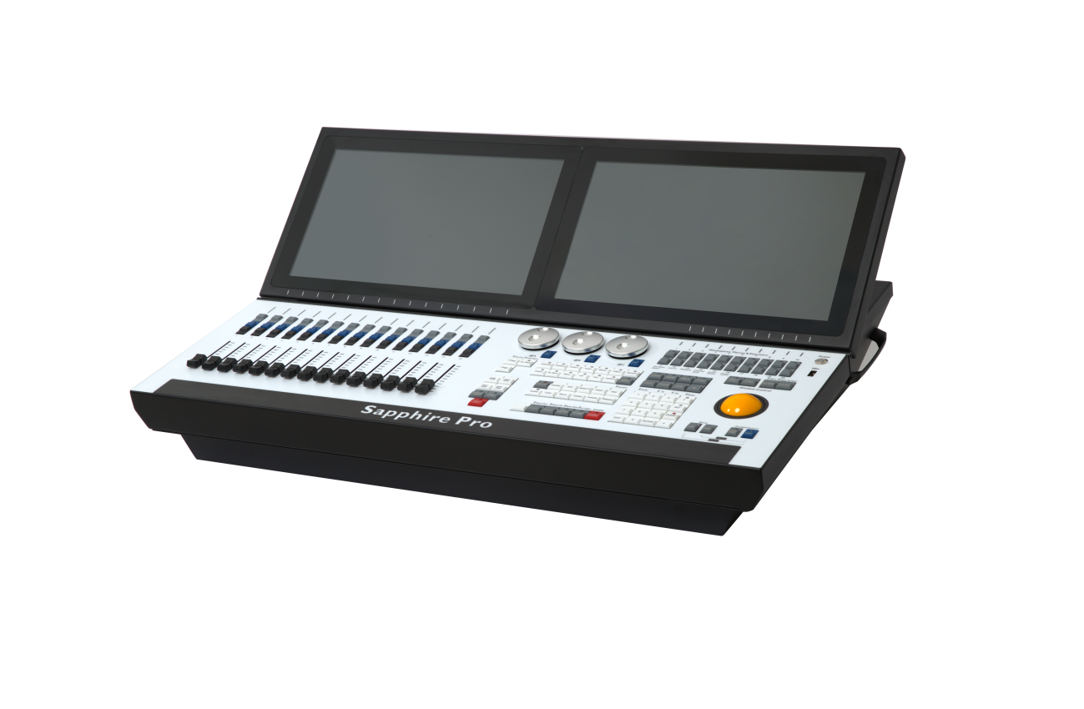

**Sapphire pro**

• Titan windows 10 operating system

• i7CPU, 8G memory, 120G solid state drive

• Built-in 8 languages, supports Chinese menu display

• Built-in 2 15.6-inch capacitive widescreen touch screens, electric lifting screen

• 15 page-turning electric pushrods, 20 macro buttons

• Built-in high-power UPS power supply, the console can be started without being connected to 220V AC power supply

• 16 output ports

• 1 LTC time code trigger port

• Supports Titan network expansion, which can be expanded to 32768 channel parameters

• 3 backlit high-precision encoding wheels

• 20 custom programmable macro function execution keys

• 1 Ethernet interface, 3 USB interfaces

• 1 control X/Y axis trackball

• Supports SMPTE and MIDI timecode

• Console built-in 3D visualization software

• Comes with one-click restore system

• Product weight: 44kg

• flight case packaging: 64x33x90cm