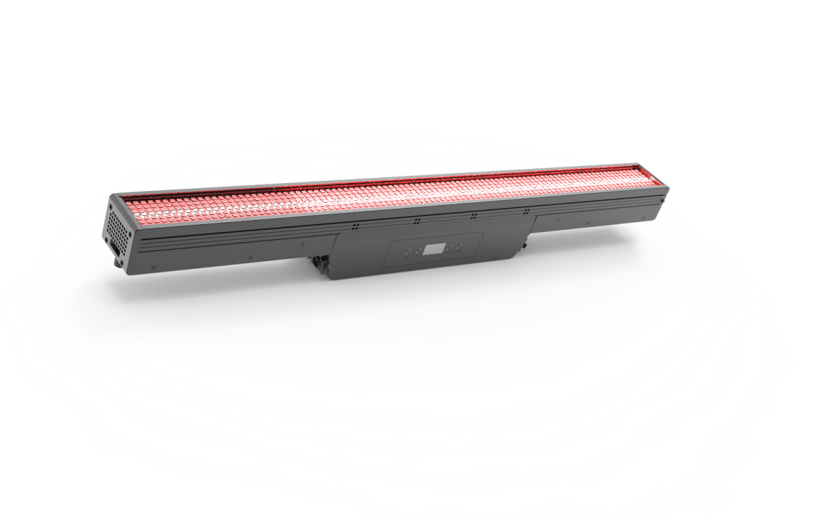

**THUNDER RHYTHM LED FULL SPECTRUM STROBE BAR**

**PL-STB1632**

Note: This manual contains important information on how to install and use safely, please read it carefully and install and operate as required, and please keep this manual properly in case you need it.

Content

1 Safety Guidance ----------------------------------------------------------------------------------------------------01

2 Dimensional drawing -----------------------------------------------------------------------------------------------02

3 Control panel ------------------------------------------------------------------------------------- -----------------03

4 Data sheet ------------------------------------------------------ --------------------------------------- -------04

5 Menu function ---------------------------------------------------------------------------------- ------- ------------05

6. Installation and connection ----------------------------------------------------------------------------------------08

6.1Installation Schematic and Precautions ---------------------------------------------------- ----------------08

6.2 Power connection ------------------------------------------------------------------------------------- -------09

6.3 Signal connection ------------------------------------------------------------------------------- --------------10

6.4 DMX channel table --------------------------------------------------------------------------------- -----------12

7 Troubleshooting ----------------------------------------------------------------------------------------- -------------24

Please read this manual thoroughly before using this lamp

1. **Safety Instructions**

|  |
| --- |
| The products are packaged in good condition, please follow the user manual, |
| Machine failure caused by human causes is not covered by the warranty. |



Warning

● The light source in this luminaire should be replaced by the manufacturer or its service agent or similarly qualified person. If this fixture has an external soft cable or

The cord is damaged and is to be replaced by a qualified person from the manufacturer or its service agent to avoid danger.

● After receiving the lamp, please open the package to check whether there is damage caused by transportation, if there is damage, do not use this lamp, and quickly with the supply

Contact the vendor or manufacturer.

● This product is suitable for indoor use, its protection level is IP65, lamps should be kept clean, avoid in humid or excessive dust environment

Use, should be carried out every three months: maintenance.

● Only qualified professionals can carry out the installation, operation and maintenance of lamps and ensure that they operate in strict accordance with the procedures described in this note

Make.

● The lamp should be installed in a well-ventilated place, at least 50CM away from the wall, and check whether the ventilation holes are unobstructed. Do not look directly at the light

source, so as not to cause damage to the eyes.

● Please do not open the lamp to repair yourself.

● The part where the electrical connection is made must require a qualified installer to operate.

● Each lamp should be safely grounded and installed electrically according to relevant standards.

● Do not use the power cord whose insulation has been damaged, and do not put the power cord on other wires, when the lamp is not used or cleaned

, unplug the power cord and do not unplug or drag the power cord directly.

● If the back cover of the lamp is equipped with a safety buckle or connection hole, for safety reasons, please use the safety rope to penetrate the connecting hole for auxiliary hoisting.

● After 10 minutes of full power work, the surface of the lamp is about 40 degrees, and the temperature of the surface of the lamp should be about 70 degrees after stable work.

● There is no user-repairable part inside this lamp, before starting to operate the lamp, please check whether all parts are well connected,

Whether the screw is reliable and fast.

● If you still have any doubts, please contact the supplier or manufacturer in time.

01

1. **Dimension**

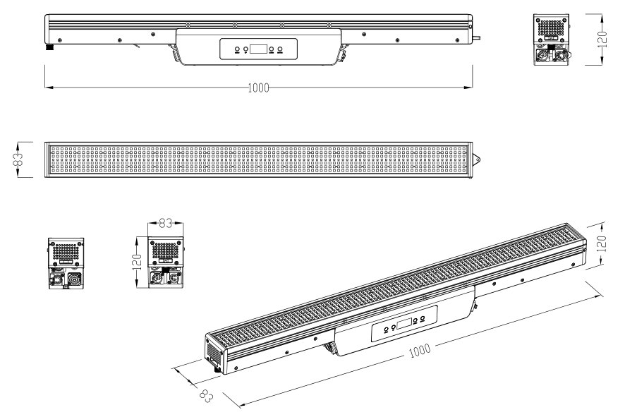

02

1. **Control Panel**

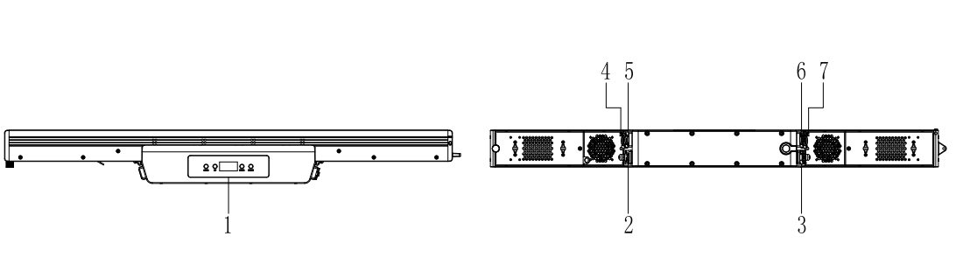

1. Panel operation buttons: mode, UP, Down, Enter

2. Power input: waterproof POWER CON power cord Input voltage: 100-240V 50/60HZ

3. Power output: waterproof POWER CON power cable Output voltage: 100-240V 50/60HZ

4.ART-NET input: Connection network input

5. DMX input: 3-core DMX waterproof signal line input

6. DMX output: 3-core DMX waterproof signal line output

7.ART-NET output: Connect to the network output

The following table describes the panel functions：

Displays a description of the panel's features

|  |  |  |  |
| --- | --- | --- | --- |
| Function | Instruction | Feature description | Role |
| MENU | Menu selection | Back to menu | Menu action |
| UP | Up | Previous option | Change parameter increase |
| DOWN | Down | Latter option | Change parameter decrease |
| ENTER | Enter | Confirm | Save the final parameters |

03

**4.Luminaire parameters**

**4.1 Technical data table**

|  |  |
| --- | --- |
| **Optical parameters** |  |
| light source | 96PCS 5W WHITE 3535 LED，576PCS 0.6W RGB 5050 LED |
| Temperature | 2800K-8000K |
| The light output of the whole machine | R:8640 Lm；G：17280 lm；B：4032 lm；W：24500 lm；ALL：23350 lm |
| illuminance | ALL:408 Lux；R：140 Lux；G：384 Lux；B：61 Lux；W：509 Lux @5m |
| Color rendering index | Ra≥90 |
| R9 | ≥90 |
| Dominant wavelength | R：625nm；G：525nm；B：458nm |
| Light source life | 20000小时 |
| Beam angle | 110° |
|  |  |
| **Dynamic effects** |  |
| Strobe | 0～20Hz |
| Dimming | Four dimming curves, 0~100% dimming |
|  |  |
| **Electronic parameters** |  |
| Input voltage and frequency | 100～240VAC,50～60Hz |
| power | Full brightness 400W, strobe 700W |
| Power connection | Waterproof POWERCORN input/output; The maximum number of connections is 9 @230V |
| Signal connection | Waterproof 3-core DMX signal line input/output, maximum number of connections 32; Waterproof network signal input and output |
| Power factor | 0.95 @230V |
| Working environment | -10°～45° |
| Switching power supply | 100～240VAC, 50～60Hz,24V 350W |
|  |  |
| **Structural parameters** |  |
| size | size：1000×120×83 mm |
| weight | N.W.：7.1Kg(clamp and bracket not included） |
| Degree of protection | IP65 |
| Heat dissipation system | Waterproof and low-noise fan forced heat dissipation |
| enclosure | Die-cast magnesium + aluminum profile; black |
| Installation method | Side hanging, hanging installation |
|  |  |
| **control** |  |
| Control mode | Art-net/DMX512/RDM |
| DMX channel | 7/15/21/39/112/17/33/65/68/117CH |
| display | OLED |
| Refresh rate | 600Hz/1200 Hz/2000 Hz/4000 Hz/6000 Hz/25KHz |
| Pixel matrix | 白光16*彩光32 |

04

|  |  |
| --- | --- |
| **fittings** |  |
| Standard | Common power cord 1PCS; Instruction manual 1PCS |
| Matching | Atomized plate seat assembly 1PCS; 60°grid 1PCS; Light barrier 1PCS |

**5 Menu function**

|  |  |  |  |  |  |  |
| --- | --- | --- | --- | --- | --- | --- |
| Menu | | | | | | |
| NO | Main Menu | Menu level 2 | Menu level 3 | | Menu level 4 |  |
| 1 | DMX Address | <001> |  | |  | Default: 001 |
| 2 | DMX Channel | 7Ch | Preset CCTS | | ...... | Default: 15Ch |
| Manual Color Mixer | | ...... |
| 15Ch |  | |  |
| 21Ch |
| 39Ch |
| 112Ch |
| 17Ch |
| 33Ch |
| 65Ch |
| 68Ch |
| 117Ch |
| 70Ch |
| 3 | Static | Preset CCTS | 2800K | | Dimmer<0-100>  Hue<-25~25> | Default: 2800K |
| 2900K | |
| 3000K | |
| 3100K | |
| 3200K | |
| ...... | |
| ...... | |
| ...... | |
| 5300K | |
| 5400K | |
| 5500K | |
| 5700K | |
| 6000K | |
| 6500K | |
| 7000K | |
| 7500K | |
| 8000K | |
|  |  | Manual Color Mixer | Red | <0-255> |  | Default：all=255 |
| Green | <0-255> |
| Blue | <0-255> |
| White | <0-255> |

05

**5 Menu function (continued)**

|  |  |  |  |  |  |
| --- | --- | --- | --- | --- | --- |
| 4 | Effect Macros | Auto1  Auto2  Auto3  Auto4  Auto5  Auto6  Auto7  Auto8  Auto9  Auto10  Auto11  Auto12  Auto13  Auto14  Auto15  Auto16  Auto17  Auto18  Auto19  Auto20  Auto21  Auto22  Auto23 | Speed<1-100> |  | Default:Auto1  Speed:100  Foreground=R  Background=Black |
| Foreground | Black |
| R |
| G |
| B |
| W |
| GB |
| RB |
| RG |
| RGB |
| RW |
| GW |
| BW |
| RGW |
| RBW |
| GBW |
| RGBW |
| Background | Black |
| R |
| G |
| B |
| W |
| GB |
| RB |
| RG |
| RGB |
| RW |
| GW |
| BW |
| RGW |
| RBW |
| GBW |
| RGBW |
| 5 | Master/Slave | Master |  |  | Default：Slave |
| Slave |
| 6 | Dimmer Curve | S Curve |  |  | Default：Linear |
| Linear |
| Square |
| Inverse Square |

06

**5 Menu function (continued)**

|  |  |  |  |  |  |  |
| --- | --- | --- | --- | --- | --- | --- |
| 7 | Dimmer Mode | Off |  | |  | Default:Off |
| Dimmer1 |
| Dimmer2 |
| Dimmer3 |
| 8 | Color Calibration | Off |  | |  | Default:Factory Calibration |
| User Calibration | Red | <0-255> |
| Green | <0-255> |
| Blue | <0-255> |
| White | <0-255> |
| Factory Calibration |  | |
| 9 | LED Frequency | 600Hz |  | |  | Default:1200Hz |
| 1200Hz |
| 2000Hz |
| 4000Hz |
| 6000Hz |
| 25KHz |
| 10 | Fan Mode | Auto |  | |  | Default:Auto |
| On |
| Off |  | |  |  |
| Silent |  | |  |  |
| 11 | Back Light | 10S |  | |  | Default:2Min |
| 30S |
| 2Min |
| Always On |
| 12 | Ethernet Setting | Protocol | Only Art-Net | |  | Default：Only Art-Net |
| Art-Net+DMX | |
| Universe | 0-255 | |  | Default：0 |
| Start Channel | 1-512 | |  | Default：1 |
| IP Address | 2/10.xxx.xxx.xxx | |  | 可设置2/10.xxx.xxx.xxx段 IP |
| Ethernet To DMX | No | |  |  |
| Yes | |
| 13 | Mapping Reverse | Off |  | |  | Default: Off |
| On |
| 14 | Language(语言) | English |  | |  |  |
| Chinese |

07

**5 Menu function (continued)**

|  |  |  |  |  |  |
| --- | --- | --- | --- | --- | --- |
| 15 | Information | Fixture Hours | 65000H |  |  |
| LED Hours | 65000H |
| Disp Version | V1.0 |
| Drv Version | V0.10 |
| UID: | 030F0940**** |
| 16 | Factory Reset | No |  |  | Default:No |

**6. Install and connect**

**6.1.1 Installation diagram**

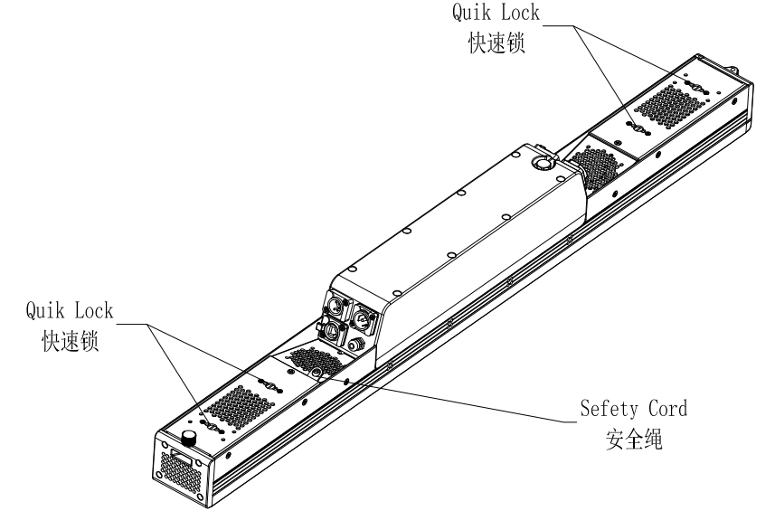

6.1.2 Notes

This product is suitable for indoor and outdoor use, its protection level is IP65, lamps should be kept clean, avoid use in humid or excessive dust environment, should be maintained every three months.

Only qualified professionals can carry out the installation, operation and maintenance of luminaires and guarantee that they are operated in strict accordance with the procedures described in this note.

THE LAMP SHOULD BE INSTALLED IN A WELL-VENTILATED PLACE, AT LEAST 50CM AWAY FROM THE WALL, AND CHECK WHETHER THE VENTILATION HOLES ARE UNOBSTRUCTED. Do not look directly at the light source to avoid damage to the eyes.

The section where the electrical connection is made must require a qualified installer to operate.

Each lamp should be safely grounded and electrically installed according to the relevant standards.

Do not use the power cord that has been damaged by the insulation layer, and do not put the power cord on other wires, when the lamp is not in use or clean, please unplug the power cord, do not pull or drag the power cord directly.

If the back cover of the lamp is equipped with a safety buckle or a connecting hole, for safety reasons, please use a safety rope to penetrate the connecting hole for auxiliary hoisting.08

**6.2 Power connection**

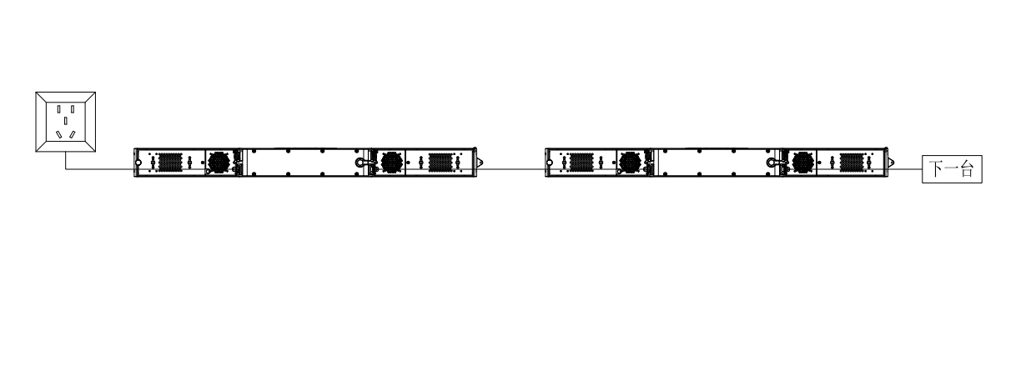

|  |
| --- |
| This product uses Power In/Out |
| Connect the power cord hand in hand |
| Note: A 1.0 square power cord due to power |
| Up to 9 units (230V) |

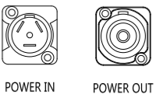

|  |
| --- |
| A single power cord should never be connected to too many lamps or overloaded. |
| Do not use power cords that have been damaged by the insulation and do not tie the power cord to other wires. |
| When the lamp is not in use or clean, unplug the power cord. |
| Do not unplug or drag the power cord vigorously. |



Warning

09

**6.3 Signal connection**

Art net

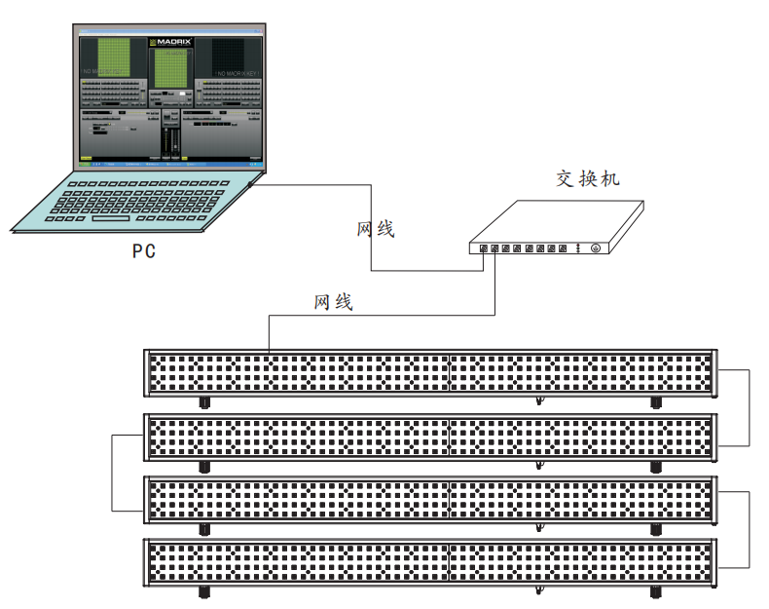

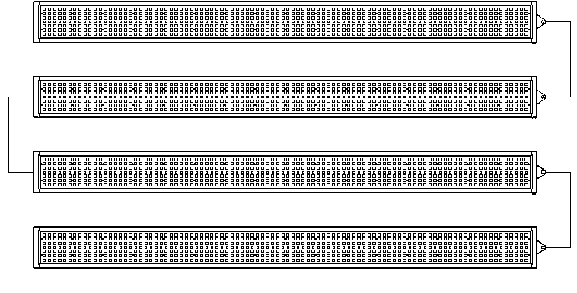

DMX Connection

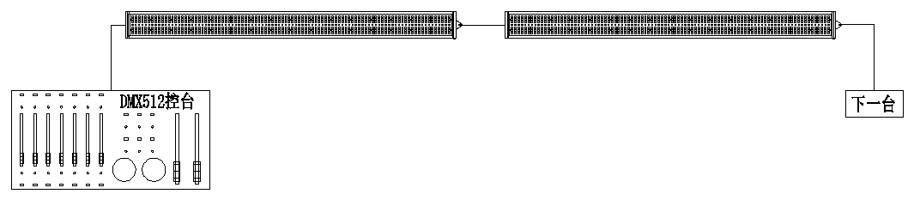

10

DMX Connection Instruction

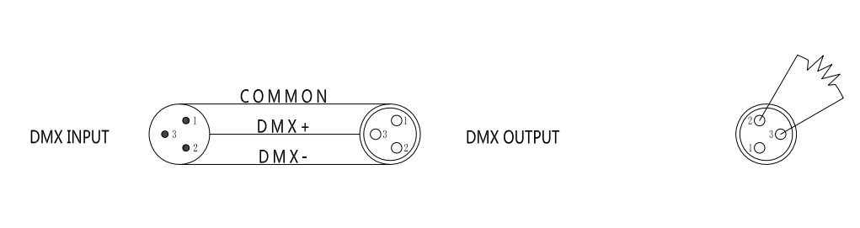

In order to reduce signal errors and avoid signal weakening and interference during transmission, a 120 ohm 1/4W resistor can be added between the 2 and 3 cores of the DMX output of the last machine.

Connect the luminaire with an XLR signal line, one end is connected to the output port of the luminaire, and the other end is connected to the input port of the next luminaire. Signal lines can only be used in series, not in parallel.

Because DMX512 signal transmission speed is fast, when the signal line is damaged, the welding place is not firm, the contact is not good, etc., it will affect the signal transmission, resulting in the system shutdown.

When the machine power supply of a unit is broken, the connection between the DMX output and input is bypassed in order to maintain the connection of the DMX line.

Each lamp must have an address code that can receive information from the console.

The terminals of the DMX512 system need to be equipped with a terminator to reduce signal transmission errors.

DMX Address Code Device

|  |  |  |  |  |  |
| --- | --- | --- | --- | --- | --- |
| Channel | Address | First address | Second address | Third address | Fourth address |
| 7CH | 001-007 | 001 | 008 | 015 | 022 |
| 15CH | 001-015 | 001 | 016 | 031 | 046 |
| 21CH | 001-021 | 001 | 022 | 043 | 064 |
| 39CH | 001-039 | 001 | 040 | 079 | 118 |
| 112CH | 001-112 | 001 | 113 | 225 | 337 |
| 17CH | 001-017 | 001 | 018 | 035 | 052 |
| 33CH | 001-033 | 001 | 034 | 067 | 0100 |
| 65CH | 001-065 | 001 | 066 | 131 | 196 |
| 68CH | 001-068 | 001 | 069 | 137 | 205 |
| 117CH | 001-117 | 001 | 118 | 235 | 352 |

(refer to the picture above) the number of lamps added after the fourth set; The address code is based on the channel, and the order is pushed

11

6.4.1 Channel sheet

|  |  |  |  |  |
| --- | --- | --- | --- | --- |
| DMX Channel(-) | | | | |
| 7CH | Function | Value | Percent/Setting | Remark |
| 1 | Red | 000-255 | 0-100% |  |
| 2 | Green | 000-255 | 0-100% |  |
| 3 | Blue | 000-255 | 0-100% |  |
| 4 | White | 000-255 | 0-100% |  |
| 5 | Dimmer Intensity | 000-004 | No function |  |
| 005-255 | Dimmer Intensity:Intensity  0 to 100% |  |
|  |
| 6 | Dimmer Fine | 000-255 | Dimmer Fine: 0 to 100% |  |
| 7 | FROST | 000-255 | FROST:0 to 100% |  |

|  |  |  |  |  |
| --- | --- | --- | --- | --- |
| 15CH | Function | Value | Percent/Setting | Remark |
| 1 | Red | 000-255 | 0-100% |  |
| 2 | Green | 000-255 | 0-100% |  |
| 3 | Blue | 000-255 | 0-100% |  |
| 4 | White | 000-255 | 0-100% |  |
| 5 | Color | 000-255 |  |  |
| 6 | Dimmer Intensity | 000-004 | No function |  |
| 005-255 | Dimmer Intensity:Intensity  0 to 100% |  |
| 7 | Dimmer Fine | 000-255 | Dimmer Fine: 0 to 100% |  |
| 8 | Strobe Duration | 000-255 |  |  |
| 9 | Strobe Rate | 000-006 | Blackout |  |
| 007-255 | Strobe Rate |  |
| 10 | Effect Macro | 000-005 | No effect |  |
| 006-050 | Ramp up |  |
| 051-100 | Ramp down |  |
| 101-150 | Ramp up-down |  |
| 151-200 | Lightning |  |
| 201-255 | Random |  |
| 11 | Backlight Macro | 000-023 | No function |  |
| 024-031 | Macro1 |  |
| 032-039 | Macro2 |  |
| 040-047 | Macro3 |  |
| 048-055 | Macro4 |  |
| 056-063 | Macro5 |  |
| 064-071 | Macro6 |  |
| 072-079 | Macro7 |  |
| 080-087 | Macro8 |  |

12

6.4.2 Channel sheet

|  |  |  |  |  |
| --- | --- | --- | --- | --- |
| 11 | Backlight Macro | 088-095 | Macro9 |  |
| 096-103 | Macro10 |  |
| 104-111 | Macro11 |  |
| 112-129 | Macro12 |  |
| 130-137 | Macro13 |  |
| 138-145 | Macro14 |  |
| 146-153 | Macro15 |  |
| 154-161 | Macro16 |  |
| 162-169 | Macro17 |  |
| 170-177 | Macro18 |  |
| 178-185 | Macro19 |  |
| 186-193 | Macro20 |  |
| 194-201 | Macro21 |  |
| 202-209 | Macro22 |  |
| 210-217 | Macro23 |  |
| 218-223 | Macro24 |  |
| 224-231 | Macro25 |  |
| 232-239 | Macro26 |  |
| 240-247 | Macro27 |  |
| 248-255 | Macro28 |  |
| 12 | Mainlight Macro | 000-090 | No function |  |
| 091-105 | Macro1 |  |
| 106-120 | Macro2 |  |
| 121-135 | Macro3 |  |
| 136-150 | Macro4 |  |
| 151-165 | Macro5 |  |
| 166-180 | Macro6 |  |
| 181-195 | Macro7 |  |
| 196-210 | Macro8 |  |
| 211-225 | Macro9 |  |
| 226-240 | Macro10 |  |
| 241-255 | Macro11 |  |
| 13 | Macro_Speed | 000-255 | Macro_Speed |  |
| 14 | Fade | 000-255 | Fade |  |
| 15 | FROST | 000-255 | FROST:0 to 100% |  |

|  |  |  |  |  |
| --- | --- | --- | --- | --- |
| 21CH | Function | Value | Percent/Setting | Remark |
| 1 | Red | 000-255 | 0-100% |  |
| 2 | Green | 000-255 | 0-100% |  |
| 3 | Blue | 000-255 | 0-100% |  |

13

6.4.3 Channel sheet

|  |  |  |  |  |
| --- | --- | --- | --- | --- |
| 4 | Color | 000-255 |  |  |
| 5 | Dimmer Intensity | 000-004 | No function |  |
| 005-255 | Dimmer Intensity:Intensity  0 to 100% |  |
| 6 | Dimmer Fine | 000-255 | Dimmer Fine: 0 to 100% |  |
| 7 | Strobe Duration | 000-255 | Strobe Duration |  |
| 8 | Strobe Rate | 000-006 | Blackout |  |
| 007-255 | Strobe Rate |  |
| 9 | Effect Macro | 000-005 | No effect |  |
| 006-050 | Ramp up |  |
| 051-100 | Ramp down |  |
| 101-150 | Ramp up-down |  |
| 151-200 | Lightning |  |
| 201-255 | Random |  |
| 10 | Backlight Macro | 000-023 | No function |  |
| 024-031 | Macro1 |  |
| 032-039 | Macro2 |  |
| 040-047 | Macro3 |  |
| 048-055 | Macro4 |  |
| 056-063 | Macro5 |  |
| 064-071 | Macro6 |  |
| 072-079 | Macro7 |  |
| 080-087 | Macro8 |  |
| 088-095 | Macro9 |  |
| 096-103 | Macro10 |  |
| 104-111 | Macro11 |  |
| 112-129 | Macro12 |  |
| 130-137 | Macro13 |  |
| 138-145 | Macro14 |  |
| 146-153 | Macro15 |  |
| 154-161 | Macro16 |  |
| 162-169 | Macro17 |  |
| 170-177 | Macro18 |  |
| 178-185 | Macro19 |  |
| 186-193 | Macro20 |  |
| 194-201 | Macro21 |  |
| 202-209 | Macro22 |  |
| 210-217 | Macro23 |  |
| 218-223 | Macro24 |  |

14

6.4.4 Channel sheet

|  |  |  |  |  |
| --- | --- | --- | --- | --- |
| 10 | Backlight Macro | 224-231 | Macro25 |  |
| 232-239 | Macro26 |  |
| 240-247 | Macro27 |  |
| 248-255 | Macro28 |  |
| 11 | Macro_Speed | 000-255 |  |  |
| 12 | RGB_Fade | 000-255 |  |  |
| 13 | Dimmer Intensity | 000-004 | No function |  |
| 005-255 | Dimmer Intensity:Intensity  0 to 100% |  |
| 14 | Dimmer Fine | 000-255 | Dimmer Fine: 0 to 100% |  |
| 15 | Strobe Duration | 000-255 | Strobe Duration |  |
| 16 | Strobe Rate | 000-006 | Blackout |  |
| 007-255 | Strobe Rate |  |
| 17 | Effect Macro | 000-005 | No effect |  |
| 006-050 | Ramp up |  |
| 051-100 | Ramp down |  |
| 101-150 | Ramp up-down |  |
| 151-200 | Lightning |  |
| 201-255 | Random |  |
| 18 | Mainlight Macro | 000-090 | No function |  |
| 091-105 | Macro1 |  |
| 106-120 | Macro2 |  |
| 121-135 | Macro3 |  |
| 136-150 | Macro4 |  |
| 151-165 | Macro5 |  |
| 166-180 | Macro6 |  |
| 181-195 | Macro7 |  |
| 196-210 | Macro8 |  |
| 211-225 | Macro9 |  |
| 226-240 | Macro10 |  |
| 241-255 | Macro11 |  |
| 19 | Macro_Speed | 000-255 |  |  |
| 20 | White_Fade | 000-255 |  |  |
| 21 | FROST | 000-255 |  |  |

|  |  |  |  |  |
| --- | --- | --- | --- | --- |
| 39CH | Function | Value | Percent/Setting | Remark |
| 1 | Red1 | 000-255 | 0-100% |  |
| 2 | Green1 | 000-255 | 0-100% |  |
| 3 | Blue1 | 000-255 | 0-100% |  |
| 4 | Red2 | 000-255 | 0-100% |  |

15

6.4.5 Channel sheet

|  |  |  |  |  |
| --- | --- | --- | --- | --- |
| 5 | Green2 | 000-255 | 0-100% |  |
| 6 | Blue2 | 000-255 | 0-100% |  |
| 7 | Red3 | 000-255 | 0-100% |  |
| 8 | Green3 | 000-255 | 0-100% |  |
| 9 | Blue3 | 000-255 | 0-100% |  |
| 10 | Red4 | 000-255 | 0-100% |  |
| 11 | Green4 | 000-255 | 0-100% |  |
| 12 | Blue4 | 000-255 | 0-100% |  |
| 13 | Red5 | 000-255 | 0-100% |  |
| 14 | Green5 | 000-255 | 0-100% |  |
| 15 | Blue5 | 000-255 | 0-100% |  |
| 16 | Red6 | 000-255 | 0-100% |  |
| 17 | Green6 | 000-255 | 0-100% |  |
| 18 | Blue6 | 000-255 | 0-100% |  |
| 19 | Red7 | 000-255 | 0-100% |  |
| 20 | Green7 | 000-255 | 0-100% |  |
| 21 | Blue7 | 000-255 | 0-100% |  |
| 22 | Red8 | 000-255 | 0-100% |  |
| 23 | Green8 | 000-255 | 0-100% |  |
| 24 | Blue8 | 000-255 | 0-100% |  |
| 25 | Dimmer Intensity | 000-004 | No function |  |
| 005-255 | Dimmer Intensity:Intensity  0 to 100% |  |
| 26 | Dimmer Fine | 000-255 | Dimmer Fine: 0 to 100% |  |
| 27 | Strobe Duration | 000-255 |  |  |
| 28 | Strobe Rate | 000-006 | Blackout |  |
| 007-255 | Strobe Rate |  |
| 29 | Effect Macro | 000-005 | No effect |  |
| 006-050 | Ramp up |  |
| 051-100 | Ramp down |  |
| 101-150 | Ramp up-down |  |
| 151-200 | Lightning |  |
| 201-255 | Random |  |
| 30 | White1 | 000-255 | 0-100% |  |
| 31 | White2 | 000-255 | 0-100% |  |
| 32 | White3 | 000-255 | 0-100% |  |
| 33 | White4 | 000-255 | 0-100% |  |
| 34 | Dimmer Intensity | 000-004 | No function |  |
| 005-255 | Dimmer Intensity:Intensity  0 to 100% |  |

16

6.4.6 Channel sheet

|  |  |  |  |  |
| --- | --- | --- | --- | --- |
| 35 | Dimmer Fine | 000-255 | Dimmer Fine: 0 to 100% |  |
| 36 | Strobe Duration | 000-255 |  |  |
| 37 | Strobe Rate | 000-006 | Blackout |  |
| 007-255 | Strobe Rate |  |
| 38 | Effect Macro | 000-005 | No effect |  |
| 006-050 | Ramp up |  |
| 051-100 | Ramp down |  |
| 101-150 | Ramp up-down |  |
| 151-200 | Lightning |  |
| 201-255 | Random |  |
| 39 | FROST | 000-255 |  |  |

|  |  |  |  |  |
| --- | --- | --- | --- | --- |
| 112CH | Function | Value | Percent/Setting | Remark |
| 1 | Red1 | 000-255 | 0-100% |  |
| 2 | Green1 | 000-255 | 0-100% |  |
| 3 | Blue1 | 000-255 | 0-100% |  |
| 4 | Red2 | 000-255 | 0-100% |  |
| 5 | Green2 | 000-255 | 0-100% |  |
| 6 | Blue2 | 000-255 | 0-100% |  |
| 7 | Red3 | 000-255 | 0-100% |  |
| 8 | Green3 | 000-255 | 0-100% |  |
| 9 | Blue3 | 000-255 | 0-100% |  |
| 10 | Red4 | 000-255 | 0-100% |  |
| 11 | Green4 | 000-255 | 0-100% |  |
| 12 | Blue4 | 000-255 | 0-100% |  |
| 13 | Red5 | 000-255 | 0-100% |  |
| 14 | Green5 | 000-255 | 0-100% |  |
| 15 | Blue5 | 000-255 | 0-100% |  |
| 16 | Red6 | 000-255 | 0-100% |  |
| 17 | Green6 | 000-255 | 0-100% |  |
| 18 | Blue6 | 000-255 | 0-100% |  |
| ... | ...... | ...... | ...... |  |
| 94 | Red32 | 000-255 | 0-100% |  |
| 95 | Green32 | 000-255 | 0-100% |  |
| 96 | Blue32 | 000-255 | 0-100% |  |
| 97 | White1 | 000-255 | 0-100% |  |
| 98 | White2 | 000-255 | 0-100% |  |
| 99 | White3 | 000-255 | 0-100% |  |
| 100 | White4 | 000-255 | 0-100% |  |
| ... | ...... | ...... | ...... |  |
| 112 | White16 | 000-255 | 0-100% |  |

17

6.4.7 Channel sheet

|  |  |  |  |  |
| --- | --- | --- | --- | --- |
| 17CH | Function | Value | Percent/Setting | Remark |
| 1 | Red1 | 000-255 | 0-100% |  |
| 2 | Green1 | 000-255 | 0-100% |  |
| 3 | Blue1 | 000-255 | 0-100% |  |
| 4 | Red2 | 000-255 | 0-100% |  |
| 5 | Green2 | 000-255 | 0-100% |  |
| 6 | Blue2 | 000-255 | 0-100% |  |
| 7 | Red3 | 000-255 | 0-100% |  |
| 8 | Green3 | 000-255 | 0-100% |  |
| 9 | Blue3 | 000-255 | 0-100% |  |
| 10 | Red4 | 000-255 | 0-100% |  |
| 11 | Green4 | 000-255 | 0-100% |  |
| 12 | Blue4 | 000-255 | 0-100% |  |
| 13 | White1 | 000-255 | 0-100% |  |
| 14 | White2 | 000-255 | 0-100% |  |
| 15 | White3 | 000-255 | 0-100% |  |
| 16 | White4 | 000-255 | 0-100% |  |
| 17 | FROST | 000-255 |  |  |

|  |  |  |  |  |
| --- | --- | --- | --- | --- |
| 33CH | Function | Value | Percent/Setting | Remark |
| 1 | Red1 | 000-255 | 0-100% |  |
| 2 | Green1 | 000-255 | 0-100% |  |
| 3 | Blue1 | 000-255 | 0-100% |  |
| 4 | Red2 | 000-255 | 0-100% |  |
| 5 | Green2 | 000-255 | 0-100% |  |
| 6 | Blue2 | 000-255 | 0-100% |  |
| 7 | Red3 | 000-255 | 0-100% |  |
| 8 | Green3 | 000-255 | 0-100% |  |
| 9 | Blue3 | 000-255 | 0-100% |  |
| 10 | Red4 | 000-255 | 0-100% |  |
| 11 | Green4 | 000-255 | 0-100% |  |
| 12 | Blue4 | 000-255 | 0-100% |  |
| 13 | Red5 | 000-255 | 0-100% |  |
| 14 | Green5 | 000-255 | 0-100% |  |
| 15 | Blue5 | 000-255 | 0-100% |  |
| 16 | Red6 | 000-255 | 0-100% |  |
| 17 | Green6 | 000-255 | 0-100% |  |
| 18 | Blue6 | 000-255 | 0-100% |  |
| 19 | Red7 | 000-255 | 0-100% |  |
| 20 | Green7 | 000-255 | 0-100% |  |
| 21 | Blue7 | 000-255 | 0-100% |  |

18

6.4.8 Channel sheet

|  |  |  |  |  |
| --- | --- | --- | --- | --- |
| 22 | Red8 | 000-255 | 0-100% |  |
| 23 | Green8 | 000-255 | 0-100% |  |
| 24 | Blue8 | 000-255 | 0-100% |  |
| 25 | White1 | 000-255 | 0-100% |  |
| 26 | White2 | 000-255 | 0-100% |  |
| 27 | White3 | 000-255 | 0-100% |  |
| 28 | White4 | 000-255 | 0-100% |  |
| 29 | White5 | 000-255 | 0-100% |  |
| 30 | White6 | 000-255 | 0-100% |  |
| 31 | White7 | 000-255 | 0-100% |  |
| 32 | White8 | 000-255 | 0-100% |  |
| 33 | FROST | 000-255 |  |  |

|  |  |  |  |  |
| --- | --- | --- | --- | --- |
| 65CH | Function | Value | Percent/Setting | Remark |
| 1 | Red1 | 000-255 | 0-100% |  |
| 2 | Green1 | 000-255 | 0-100% |  |
| 3 | Blue1 | 000-255 | 0-100% |  |
| 4 | Red2 | 000-255 | 0-100% |  |
| 5 | Green2 | 000-255 | 0-100% |  |
| 6 | Blue2 | 000-255 | 0-100% |  |
| 7 | Red3 | 000-255 | 0-100% |  |
| 8 | Green3 | 000-255 | 0-100% |  |
| 9 | Blue3 | 000-255 | 0-100% |  |
| 10 | Red4 | 000-255 | 0-100% |  |
| 11 | Green4 | 000-255 | 0-100% |  |
| 12 | Blue4 | 000-255 | 0-100% |  |
| 13 | Red5 | 000-255 | 0-100% |  |
| 14 | Green5 | 000-255 | 0-100% |  |
| 15 | Blue5 | 000-255 | 0-100% |  |
| 16 | Red6 | 000-255 | 0-100% |  |
| 17 | Green6 | 000-255 | 0-100% |  |
| 18 | Blue6 | 000-255 | 0-100% |  |
| ... | ...... | ...... |  |  |
| 46 | Red16 | 000-255 | 0-100% |  |
| 47 | Green16 | 000-255 | 0-100% |  |
| 48 | Blue16 | 000-255 | 0-100% |  |
| 49 | White1 | 000-255 | 0-100% |  |
| 50 | White2 | 000-255 | 0-100% |  |
| 51 | White3 | 000-255 | 0-100% |  |
| 52 | White4 | 000-255 | 0-100% |  |
| ... | ...... | ...... |  |  |

19

6.4.9 Channel sheet

|  |  |  |  |  |
| --- | --- | --- | --- | --- |
| 64 | White16 | 000-255 | 0-100% |  |
| 65 | FROST | 000-255 |  |  |

|  |  |  |  |  |
| --- | --- | --- | --- | --- |
| 68CH | Function | Value | Percent/Setting | Remark |
| 1 | Dimmer | 000-004 | No function |  |
| 005-255 | Dimmer |  |
| 2 | Backlight  Strobe  Effect | 000-007 | No Effect |  |
| 008-127 | Strobe |  |
| 128-130 | No Effect |  |
| 131-250 | Random |  |
| 251-255 | No Effect |  |
| 3 | Mainlight  Strobe  Effect | 000-007 | No Effect |  |
| 008-127 | Strobe |  |
| 128-130 | No Effect |  |
| 131-250 | Random |  |
| 251-255 | No Effect |  |
| 4 | FROST | 000-255 |  |  |
| 5 | Red1 | 000-255 | 0-100% |  |
| 6 | Green1 | 000-255 | 0-100% |  |
| 7 | Blue1 | 000-255 | 0-100% |  |
| 8 | Red2 | 000-255 | 0-100% |  |
| 9 | Green2 | 000-255 | 0-100% |  |
| 10 | Blue2 | 000-255 | 0-100% |  |
| 11 | Red3 | 000-255 | 0-100% |  |
| 12 | Green3 | 000-255 | 0-100% |  |
| 13 | Blue3 | 000-255 | 0-100% |  |
| 14 | Red4 | 000-255 | 0-100% |  |
| 15 | Green4 | 000-255 | 0-100% |  |
| 16 | Blue4 | 000-255 | 0-100% |  |
| 17 | Red5 | 000-255 | 0-100% |  |
| 18 | Green5 | 000-255 | 0-100% |  |
| 19 | Blue5 | 000-255 | 0-100% |  |
| 20 | Red6 | 000-255 | 0-100% |  |
| 21 | Green6 | 000-255 | 0-100% |  |
| 22 | Blue6 | 000-255 | 0-100% |  |
| ... | ...... | ...... |  |  |
| 50 | Red16 | 000-255 | 0-100% |  |
| 51 | Green16 | 000-255 | 0-100% |  |
| 52 | Blue16 | 000-255 | 0-100% |  |
| 53 | White1 | 000-255 | 0-100% |  |
| 54 | White2 | 000-255 | 0-100% |  |

20

6.4.10 Channel sheet

|  |  |  |  |  |
| --- | --- | --- | --- | --- |
| 55 | White3 | 000-255 | 0-100% |  |
| 56 | White4 | 000-255 | 0-100% |  |
| ... | ...... | ...... | ... |  |
| 68 | White16 | 000-255 | 0-100% |  |

|  |  |  |  |  |
| --- | --- | --- | --- | --- |
| 117CH | Function | Value | Percent/Setting | Remark |
| 1 | Dimmer | 000-004 | No function |  |
| 005-255 | Dimmer |  |
| 2 | Strobe Duration | 000-255 |  |  |
| 3 | Strobe Rate | 000-006 | Blackout |  |
| 007-255 | Strobe Rate |  |
| 4 | Effect Macro | 000-005 | No effect |  |
| 006-050 | Ramp up |  |
| 051-100 | Ramp down |  |
| 101-150 | Ramp up-down |  |
| 151-200 | Lightning |  |
| 201-255 | Random |  |
| 5 | FROST | 000-255 |  |  |
| 6 | Red1 | 000-255 | 0-100% |  |
| 7 | Green1 | 000-255 | 0-100% |  |
| 8 | Blue1 | 000-255 | 0-100% |  |
| 9 | Red2 | 000-255 | 0-100% |  |
| 10 | Green2 | 000-255 | 0-100% |  |
| 11 | Blue2 | 000-255 | 0-100% |  |
| 12 | Red3 | 000-255 | 0-100% |  |
| 13 | Green3 | 000-255 | 0-100% |  |
| 14 | Blue3 | 000-255 | 0-100% |  |
| 15 | Red4 | 000-255 | 0-100% |  |
| 16 | Green4 | 000-255 | 0-100% |  |
| 17 | Blue4 | 000-255 | 0-100% |  |
| 18 | Red5 | 000-255 | 0-100% |  |
| 19 | Green5 | 000-255 | 0-100% |  |
| 20 | Blue5 | 000-255 | 0-100% |  |
| 21 | Red6 | 000-255 | 0-100% |  |
| 22 | Green6 | 000-255 | 0-100% |  |
| 23 | Blue6 | 000-255 | 0-100% |  |
| ... | ...... | ...... | ...... |  |
| 99 | Red32 | 000-255 | 0-100% |  |
| 100 | Green32 | 000-255 | 0-100% |  |
| 101 | Blue32 | 000-255 | 0-100% |  |
| 102 | White1 | 000-255 | 0-100% |  |

21

6.4.11 Channel sheet

|  |  |  |  |  |
| --- | --- | --- | --- | --- |
| 103 | White2 | 000-255 | 0-100% |  |
| 104 | White3 | 000-255 | 0-100% |  |
| 105 | White4 | 000-255 | 0-100% |  |
| ... | ...... | ...... |  |  |
| 117 | White16 | 000-255 | 0-100% |  |

|  |  |  |  |  |
| --- | --- | --- | --- | --- |
| 70CH | Function | Value | Percent/Setting | Remark |
| 1 | Dimmer | 000-004 | No function |  |
| 005-255 | Dimmer |  |
| 2 | Backlight  Strobe  Effect | 000-007 | No Effect |  |
| 008-127 | Strobe |  |
| 128-130 | No Effect |  |
| 131-250 | Random |  |
| 251-255 | No Effect |  |
| 3 | Mainlight  Strobe  Effect | 000-007 | No Effect |  |
| 008-127 | Strobe |  |
| 128-130 | No Effect |  |
| 131-250 | Random |  |
| 251-255 | No Effect |  |
| 4 | FROST | 000-255 |  |  |
| 5 | Red1 | 000-255 | 0-100% |  |
| 6 | Green1 | 000-255 | 0-100% |  |
| 7 | Blue1 | 000-255 | 0-100% |  |
| 8 | Red2 | 000-255 | 0-100% |  |
| 9 | Green2 | 000-255 | 0-100% |  |
| 10 | Blue2 | 000-255 | 0-100% |  |
| 11 | Red3 | 000-255 | 0-100% |  |
| 12 | Green3 | 000-255 | 0-100% |  |
| 13 | Blue3 | 000-255 | 0-100% |  |
| 14 | Red4 | 000-255 | 0-100% |  |
| 15 | Green4 | 000-255 | 0-100% |  |
| 16 | Blue4 | 000-255 | 0-100% |  |
| 17 | Red5 | 000-255 | 0-100% |  |
| 18 | Green5 | 000-255 | 0-100% |  |
| 19 | Blue5 | 000-255 | 0-100% |  |
| 20 | Red6 | 000-255 | 0-100% |  |
| 21 | Green6 | 000-255 | 0-100% |  |
| 22 | Blue6 | 000-255 | 0-100% |  |
| ... | ...... | ...... |  |  |
| 50 | Red16 | 000-255 | 0-100% |  |
| 51 | Green16 | 000-255 | 0-100% |  |

22

6.4.12 Channel sheet

|  |  |  |  |  |
| --- | --- | --- | --- | --- |
| 52 | Blue16 | 000-255 | 0-100% |  |
| 53 | White1 | 000-255 | 0-100% |  |
| 54 | White2 | 000-255 | 0-100% |  |
| 55 | White3 | 000-255 | 0-100% |  |
| 56 | White4 | 000-255 | 0-100% |  |
| ... | ...... | ...... |  |  |
| 68 | White16 | 000-255 | 0-100% |  |
| 69 | RGB_Fade | 000-255 |  |  |
| 70 | White_Fade | 000-255 |  |  |

Pixels Segmentation control description

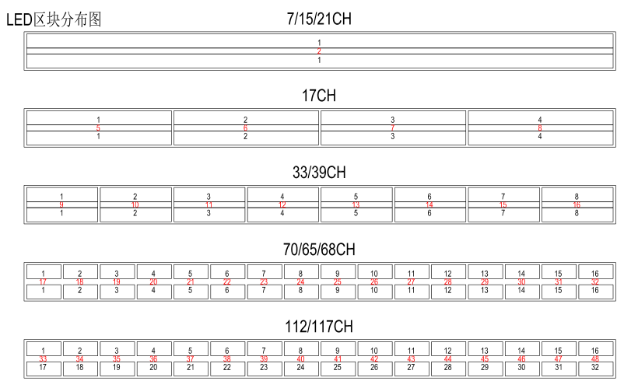

23

7 Troubleshooting

|  |  |  |
| --- | --- | --- |
| Symptom | The cause of the failure | Processing method |
| No menu display | 1.There is no AC input  2. The switching power supply is damaged  3. The display board is faulty | 1.Check the power supply line  2. Check whether the switching power supply has voltage output  3. Replace the display board |
| No DMX signal is received | 1.The DMX signal cable is faulty  2. The signal line wiring sequence is wrong  3. The signal input receiving signal IC is damaged  4. DMX address code setting and console  The corresponding controls do not match  5.Other parameters are set incorrectly  6. The confirmation key is not pressed after entering the menu  OR THE MENU KEY TO EXIT TO THE MAIN MENU | 1.Check or replace the signal cable  2. Check the wiring sequence of the signal line  3. Check the display board signal acceptance IC and  Whether the two resistors strung on the signal wire are open  4.Check or reset the address code  Or do a factory reset and try again  5. Press MENU to exit to the main menu |
| The surface temperature of the lamp body exceeds 75° | 1.The thermistor on the lamp bead plate is faulty  2. The temperature control circuit on the display board is faulty | 1.Replace the thermistor  2. Check the temperature control circuit on the motherboard |
| Temperature control protection is not possible | 1.The lamp beads are not welded correctly  2. The lens or bracket is not installed | 1.Check the bulb welding  2. Check the lens assembly process,  Adjust the bracket assembly orientation |
| The cast light mixes unevenly | The lamp beads are damaged or the driver board has no current output | 1.Replace the lamp beads  2. Replace the damaged lamp beads  Or check the driver board wiring  3. Replace the corresponding driver IC |
| There are uneven pigmentation spots | The IC used to store parameters is damaged | Replace the memory IC |
| The lamp beads are not lit or flicker a little | When the temperature is too high, temperature control protection is caused  Switching power supply overtemperature protection does not work | Wait for the lamp body to cool down before turning it on |