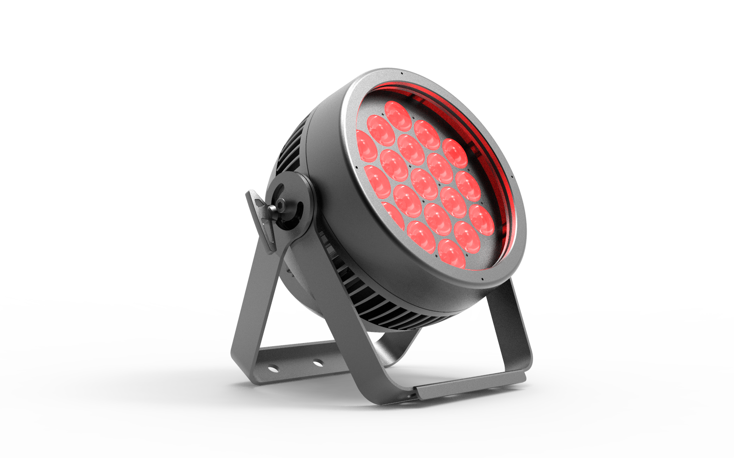

AURORA LED FULL SPECTRUM WASH LIGHT PL-PT19

Note: This manual contains important information on how to install and use safely, please read it carefully and install and operate as required, and please keep this manual properly in case you need it.

Content

Safety instructions | 3
Fixture structure and Installation | 4
DMX signal connection and description | 5
DMX address code device, power connection | 6
Control panel | 7
Menu | 8
DMX Channel | 9
Maintenance,troubleshooting | 11
Technical parameters | 12
Dimension | 13

Every unit is tested completely and packed properly by the manufacturer. Please make sure the packing and / or the unit are in good condition before installation and use. Should there be any damage caused by transportation, consult your dealer and do not use the unit. Any damage caused by improper use will not be assumed by the manufacturer and / or dealer.
Please note that as part of our ongoing commitment to continuous product development, specifications are subject to change without notice.

Safety Instructions


The products are packaged in good condition, please follow the user manual,
Machine failure caused by human causes is not covered by the warranty.
Warning
- When unpacking and before disposing of the carton check there is no transportation damage before using the light. Should there be any damage caused by transportation, consult your dealer and do not use the apparatus.

- The projector is for indoor and outdoor use, IP65.
- Do not install the fixtures onto inflammable surfaces directly.

- The fixture is only intended for installation, operation and maintenance by qualified personnel.

- Do not project the beam onto inflammable surfaces, minimum distance is 3meter. 3m

- Avoid direct exposure to the light from the lamp. The light is harmful to the eye.

- Do not attempt to dismantle and/or modify the projector in any way.

- Electrical connection must only be carried out by qualified personnel.

- Before installation, ensure that the voltage and frequency of power supply match the power requirements of the fixture.

- It is essential that each projector is correctly earthed and that electrical installation conforms to all relevant standards.

- Do not connect this device to any other types of dimmer apparatus.

- The projector should always be installed with a secondary safety fixing. A safety cord is supplied for this; it should be attached as
shown in “installing the projector” section.

- Shields and lens shall be changed if they have become visibly damaged to such an extent than their effectiveness is impaired, for example by cracks or deep scratches.

- Exterior surface temperatures of the luminaire after 5 minutes operation is 45℃, when steady state is achieved 70℃
- There is no user serviceable parts inside the projector, do not open the housing and never operate the fixture with the covers
- removed.

- If you have any questions, don’t hesitate to consult your dealer or manufacturer.

Fixture structure and installation

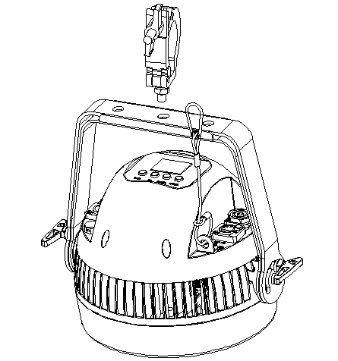

DMX signal connection and description

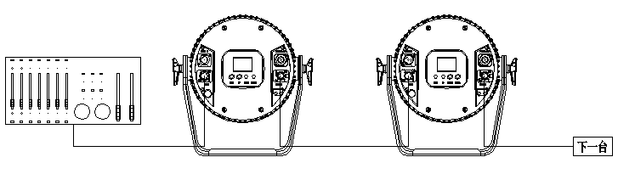

DMX Connection Instruction

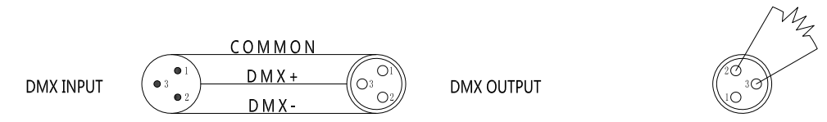

● In order to reduce signal errors and avoid signal weakening and interference during transmission,

A 120 ohm 1/4W resistor can be added between the 2 and 3 cores of the DMX output of the last machine.

● Connect the lamp with XLR signal cable, and connect one end to the output port of the lamp,

The other end is connected to the input port of the next fixture. Signal lines can only be used in series, not in parallel.

Because DMX512 signal transmission speed is very fast, when the signal line is damaged, the welding place is not firm, the contact is not good, etc.

will affect the signal transmission, causing the system to shut down.

● When the machine power supply of a unit is broken, the connection between DMX output and input is bypassed.

In order to maintain the connectivity of the DMX line.

● Each lamp must have an address code that can receive information from the console.

● The terminal of the DMX512 system needs to be equipped with a terminator to reduce signal transmission errors.

DMX Address Code Device

Channel | address | First address | Second address | Third address | Fourth address
4CH | 001-004 | 001 | 005 | 009 | 013
7CH | 001-007 | 001 | 008 | 015 | 022
8CH | 001-008 | 001 | 009 | 017 | 025
(refer to the picture above) the number of lamps added after the fourth set; The address code is based on the channel, and the order is pushed

Power Connection

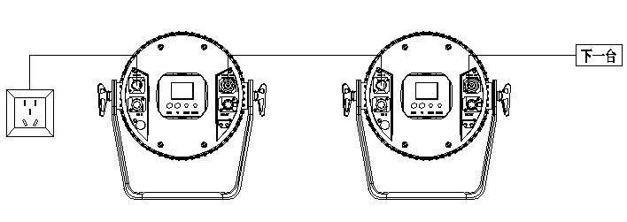

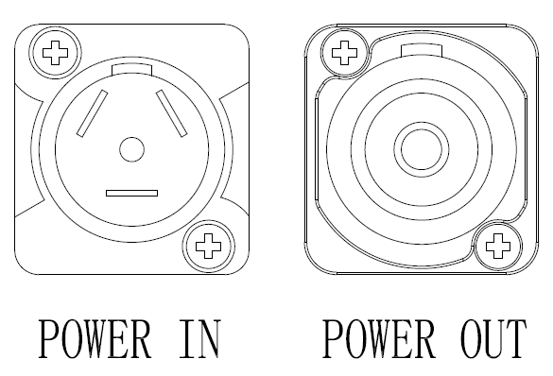
This product uses Power In/Out
Connect the power cord hand in hand
Note: A 1.5 square power cord due to power
Up to 6 units (230V)


A single power cord should never be connected to too many lamps or overloaded.
Do not use power cords that have been damaged by the insulation and do not tie the power cord to other wires.
When the lamp is not in use or clean, unplug the power cord.
Do not unplug or drag the power cord vigorously.
Warning

Control Panel

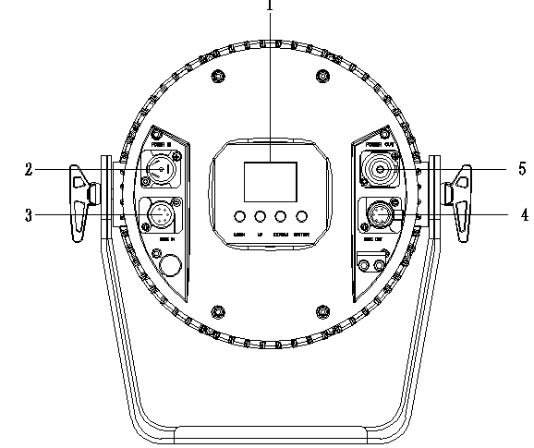

Panel operation buttons: MENU, UP, DOWN, ENTER

2. Power input: waterproof POWER IN power cord Input voltage: 100-240V 50/60HZ

3. DMX input: 3-core DMX IN waterproof signal line input

4. DMX output: 3-core DMX OUT waterproof signal line output

- Power output: waterproof POWER OUT power connection line output voltage 100-240V 50/60HZ

The following table describes the panel functions：

Displays a description of the panel's features:
Function | Instruction | Feature description | Role
MENU | Menu selection | Back to menu | Menu action
UP | Up | Previous option | Change parameter increase
DOWN | Down | Latter option | Change parameter decrease
ENTER | Enter | Confirm | Save the final parameters

Menu

Level 1 | Level 2 | Level 3
1.DMX address | 1-512
 | cancel
 | enter
2.DMX channel mode | 4 channels mode
 | 7 channels mode
 | 8 channels mode
3.Dimming mode | Dimming mode 1
 | Dimming mode 2
 | Dimming mode 3
4.Dimming curve | Dimming curve 1
 | Dimming curve 2
 | Dimming curve 3
 | Dimming curve 4
5.LED Dimming frequency | 600Hz
 | 1200Hz
 | 2000Hz
 | 4000Hz
 | 6000Hz
 | 25K Hz
6.Manual color | Red | 0-255
 | Green | 0-255
 | Blue | 0-255
 | White | 0-255
7.Self-propelled | Self-propelled color | 0-255
 | Self-propelled gradient | 0-255
8.Language | English
 | Chinese
9.Display | Normal
 | Reverse
10.Display backlight | On
 | 30 second
11.Fixture test | Red
 | Green
 | Blue
 | White
12.Factory reset | No
 | Yes
13.System information | RDM UID
 | Program version
 | DMX channel
 | Elapsed time
 | Time of use
 | temperature

Remark:
1. Only one machine can be set as the host in the same signal line, please remove the DMX control signal when using the host function
2. The parameters that can be transmitted from the host when multiple lamps are synchronously controlled include: DMX channel mode, display setting status, operation mode status (including user program data), when transferring parameters, please set the machine as the host, and other machines as slaves

DMX Channel
4 Channel
Channel mode | Function | DMX Value | DMX channel value
1 | Red | 0-255 | 0-100%
2 | Green | 0-255 | 0-100%
3 | Blue | 0-255 | 0-100%
4 | White | 0-255 | 0-100%

7 Channel
Channel mode | Function | DMX Value | DMX channel value
1 | Zoom | 0-255 | 0-100%
2 | Strobe | 0-255 | 0-100%
3 | Red | 0-255 | 0-100%
4 | Green | 0-255 | 0-100%
5 | Blue | 0-255 | 0-100%
6 | White | 0-255 | 0-100%
7 | Color temperature | 0-255 | 0-100% | default light on value1-4/0.4%-1.6%(RGBW controllable)

8 Channel
Channel | Function | DMX Value | DMX channel value
1 | Zoom | 0-255 | 0-100%
2 | Strobe | 0-255 | 0-100%
3 | Red | 0-255 | 0-100%
4 | Green | 0-255 | 0-100%
5 | Blue | 0-255 | 0-100%
6 | White | 0-255 | 0-100%
7 | Color temperature | 0-255 | 0-100% | default light on value1-4/0.4%-1.6%(RGBW controllable
8 | Macro color | 0-255 | 0-100%

Channel priority: dimming > built-in program call> user program call>ARGBW dimming>HSV dimming > macro > color temperature

Maintenance

In order to extend the service life of lamps, the maintenance of lamps is very necessary. The outdoor use environment is relatively harsh, or the lamp will be placed for a long time

Water vapor and dust accumulate in the lens cover, lamp shell and other components, and the lamp needs to be cleaned to optimize the light efficiency output, while also preventing dust and acidity

Gas causes corrosion to the housing.

The number of cleaning times depends on the frequency of operation of the luminaire and the surrounding environment. Careful wiping with a soft cloth and general glass cleaning products when cleaning is recommended

Clean at least every 20 days.

Do not wipe the lamp housing with organic solvents such as alcohol to avoid damage.

Troubleshooting

Fault description | Solution
The lamp does not start properly | - The power cord is not connected properly  - The switching power supply is damaged or the connection is not normal, and professional qualified maintenance personnel are required for maintenance  - The control board is not connected normally, and professional qualified maintenance personnel are required to overhaul
The light starts, but the LED is not lit and uncontrolled | - The LED mounting plate is not connected normally and needs to be overhauled by professional qualified maintenance personnel
The fixture lights normally, but is not controlled by the controller | - Check whether the DMX start address of the fixture is set correctly  - Check the XLR signal cable for damage
The light is dim and the brightness drops significantly | - The ambient temperature is too high to cause the lamp to overheat, please take necessary ventilation and heat dissipation measures

Technical parameters

Technical data sheet：
Optical parameters
Light source | 19pcs 15W RGBW LED
Output | 12400Lm
Color temperature | 2400K～8500K
CRI | Ra≥90,R9≥90
Beam angle | 8°/15°/25°/45°
Flooding angle
Dynamic effects
Vertical scan | Manual rotation180°
Color system | RGBW color mixed
Pixel matrix | Overall control
Strobe | 0～20Hz
Dimmer | 4 dimming curves，0～100% dimming
Power parameters
Input voltage and frequency | 100～240VAC , 50～60Hz
Power connection | Seetronic, IP66 Power IN/OUT,maximum connection 6pcs @230V
Signal connection | Seetronic, IP66 3-Pin XLR IN/OUT for DMX, maximum number of connections is 32 sets
Power | 230W@230V
Power factor | 0.95/230V
Ambient | -20～45℃
Structural parameters
Dimension | size：314*312*197/mm； packing size：336*294*255mm
weight | N.W.：7.7 kg； G.W.：8.8Kg
IP rating | IP65
Heat dissipation system | Speed control fan dissipation of heat
Shell | die-casting aluminum，black (color can be customized)
Installation method | vertical hanging, side hanging
Control
Control method | DMX512/ RDM
DMX Channel | 4CH/7CH/8CH
Display | TFT display with 4 touch buttons
Refresh rate | 600Hz/1200Hz/2000Hz/4000Hz/6000Hz/25KHz
Accessory
standard | IP65 Power line1PCS；Mannual1PCS
option | Light repellent/light barrier assembly

Dimension

