User manual

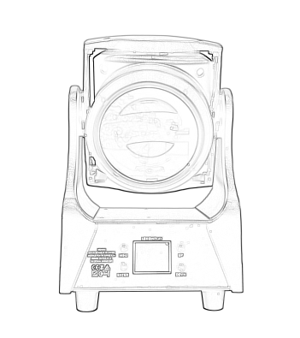
MH-B150
Please read the instructions carefully before use

TABLE OF CONTENTS
- Safety Instructions………………………………………………………………………………3
- Technical Specifications…………………………………………………………………………4
- Control Menu ………………………………………………………………………………………5-6
- DMX Channels ……………………………………………………………………………………7-8
- Trouble Shooting…………………………………………………………………………………9
- Fixture Cleaning………………………………………………………… ………………………9

STATEMENT
The product has well capability and intact packing when leave factory. All of the user should comply with warning item and manual, any misuse cause of the damages are not included in our guarantee, and also can not be responsible for any malfunction & problem owing to ignore the manual.

1.Safety Instructions
Please keep this User Guide for future consultation. If you sell the unit to another user, be sure that they also receive this instruction booklet.
•Unpack and check carefully there is no transportation damage before using the unit.
•Before operating, ensure that the voltage and frequency of power supply match the power requirements of the unit.
•It’s important to ground the yellow/green conductor to earth in order to avoid electric shock.
•The unit is for indoor use only. Use only in a dry location.
•The unit must be installed in a location with adequate ventilation, at least 50cm from adjacent surfaces. Be sure that no ventilation slots are blocked.
•Disconnect main power before replacement or servicing.
•Make sure there are no flammable materials close to the unit while operating as it is fire hazard.
•Use safety cable when fixes this unit. DO NOT handle the unit by taking its head only, but always by taking its base.
•Maximum ambient temperature is Ta: 40℃. DO NOT operate it where the temperature is higher than this Unit surface temperature may reach up to 85℃. DO NOT touch the housing bare-hand during its operation. Turn off the power and allow about 15 minutes for the unit to cool down before replacing or serving.
•the event of serious operating problem, stop using the unit immediately.Never try to repair the unit by yourself. Repairs carried out by unskilled people can lead to damage or malfunction. Please contact the nearest authorized technical assistance center. Always use the same type spare parts.
•DO NOT touch any wire during operation as high voltage might be causing electric shock.
Warning:
•To prevent or reduce the risk of electrical shock or fire, do not expose the unit to rain or moisture.
•The housing, the lenses, or the ultraviolet filter must be replaced if they are visibly damaged.
Caution:
•There are no user serviceable parts inside the unit. DO NOT open the housing or attempt any repairs yourself. In the unlikely event your unit may require service, please contact your nearest dealer.
Installation:
•The unit should be mounted via its screw holes on the bracket. Always ensure that the unit is firmly fixed to avoid vibration and slipping while operating. And make sure that the structure to which you are attaching the unit is secure and is able to support a weight of 10 times of the unit’s weight. Also always use a safety cable that can hold 12 times of the weight of the unit when installing the fixture.
•The equipment must be fixed by professionals. And it must be fixed at a place where is out of the touch of people.

2.Technical Specifications
Voltage: 180-240V~50 / 60Hz
Power :200 W
Light source:RGBL 4-in-1 LED,LED Circle: 24*0.5 W，RGB 3-in-1 LED
Beam angle: 3°-30 °
Field Angle: 4°-35°
Power socket: Power connector in / out
Signal in/ out: 3-pin or 5-pin XLR, RJ45 connector(optional)
Pan Movement: 59°
Tilt Movement:221°
Mode of control: DMX512,RDM(optional), Self-walking,Master and slave
DMX Channels: 21CH/41CH
Multiple speed strobe effects
Variable light adjustment from 0-100% dimming
Extraordinary color-mixing function
Special color macro effect
Agile fast linear focus
IP grade: IP20
Dimensions: 205*190*355mm
NW:6.32kg

3.Control Menu

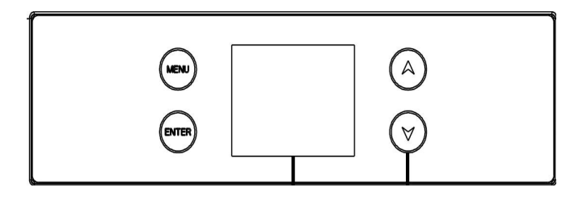

MENU |  | DMX Address | 001 - 512
MENU |  | Fixture | Channel Mode | 21CH/41CH /71CH/75CH/85CH/170CH
MENU |  | Fixture | Run Mode | DMX / Auto
MENU |  | Fixture | Pan Invert | Close/ Open
MENU |  | Fixture | Tilt Invert | Close/ Open
MENU |  | Fixture | Fan Control | Normal/Low/Quiet/High
MENU |  | Fixture | Dim Curve | Linear/Square Law/Inv SQ Law/S Curve
MENU |  | Fixture | Dim Fast Close | Close/ Open
MENU |  | Fixture | No DMX State | Clear/ Keep
MENU |  | Fixture | LED Flush | 900Hz/1000Hz/1100Hz/1200Hz/1300Hz/  1400H/1500Hz/2500Hz/4000Hz/5000Hz/  6000Hz/10KHz/15KHz/20KHz/25KHz
MENU |  | Manual | Pan 1 | 000 - 255
 |  | Pan Fine 1 | 000 - 255
 |  | Tilt 1 | 000 - 255
 |  | Tilt Fine 1 | 000 - 255
 |  | …… | ……
 | Information | Time | Current Time
 | Information | Time | Total Time
 | Information | Time | Power Count
 | Information | Sensor | Tilt 1
 | Information | Sensor | Pan 1
 | Information | Sensor | Zoom 1
 | Information | Sensor | Temp 1
 | Information | Sensor | ……
 | Information | Temperature | Head1 Temp
 | Information | Temperature | Head2 Temp
 | Information | Temperature | Head3 Temp
 | Information | Temperature | Head4 Temp
 | Information | Temperature | Head5 Temp
 | Information | Software Version | Show
 | Information | Software Version | Y Motor
 | Information | Software Version | Dimmer 1
 | Information | Software Version | Dimmer 2
 | Information | Software Version | Dimmer 3
 | Information | Software Version | Dimmer 4
 | Information | Software Version | Dimmer 5
 | Factory | Password | 000 - 255
 | Factory | Pan1 | 000 - 255
 | Factory | Tilt1 | 000 - 255
 | Factory | Zoom1 | 000 - 255
 | Factory | Pan2 | 000 - 255
 | Factory | Tilt2 | 000 - 255
 | Factory | …… | ……
 | Factory | …… | ……
 | Fix Reset | All Reset | OFF/Run
 | Fix Reset | Factory | OFF/Run
 | Display | Language | CH / EN
 | Display | Display Flip | Normal/Reverse
 | Display | Display Mode | 60s / Show

4.DMX Channels
21CH
CHANNEL | Value | FUNCTION
1 | 0-255 | Pan
2 | 0-255 | Pan Fine
3 | 0-255 | Tilt
4 | 0-255 | Tilt Fine
5 | 0-255 | Zoom
6 | 0-255 | Main Red
7 | 0-255 | Main Green
8 | 0-255 | Main Blue
9 | 0-255 | Main White
10 | 0-255 | Main CTO
11 | 0-255 | Main Color Macro
12 | 0-255 | Ring Red
13 | 0-255 | Ring Green
14 | 0-255 | Ring Blue
15 | 0-255 | Ring Effect
16 | 0-255 | Dimmer
17 | 0-255 | Dimmer Fine
18 | 0-255 | Main Strobe
19 | 0-255 | Ring Strobe
20 | 0-255 | XY Speed
21 | 0-255 | Macro

41CH
CHANNEL | Value | FUNCTION
1 | 0-255 | Pan1
2 | 0-255 | Pan Fine1
3 | 0-255 | Tilt1
4 | 0-255 | Tilt Fine1
5 | 0-255 | Zoom1
… | 0-255 | …
21 | 0-255 | Pan5
22 | 0-255 | Pan Fine5
23 | 0-255 | Tilt5
24 | 0-255 | Tilt Fine5
25 | 0-255 | Zoom5
26 | 0-255 | Main Red
27 | 0-255 | Main Green
28 | 0-255 | Main Blue
29 | 0-255 | Main White
30 | 0-255 | Main CTO
31 | 0-255 | Main Color Macro
32 | 0-255 | Ring Red
33 | 0-255 | Ring Green
34 | 0-255 | Ring Blue
35 | 0-255 | Ring Effect
36 | 0-255 | Dimmer
37 | 0-255 | Dimmer Fine
38 | 0-255 | Main Strobe
39 | 0-255 | Ring Strobe
40 | 0-255 | XY Speed
41 | 0-255 | Macro

5.Trouble Shooting
Following are a few common problems that may occur during operation. Here are some suggestions for easy troubleshooting:

A. The unit does not work, no light and the fan does not work
1. Check the connection of power and main fuse.
2. Measure the mains voltage on the main connector.
3. Check the power on LED.

B. Not responding to DMX controller
1. DMX LED should be on. If not, check DMX connectors, cables to see if link properly.
2. If the DMX LED is on and no response to the channel, check the address settings and DMX polarity.
3. If you have intermittent DMX signal problems, check the pins on connectors or on
PCB of the unit or the previous one.
4. Try to use another DMX controller.
5. Check if the DMX cables run near or run alongside to high voltage cables that may cause damage or interference to DMX interface circuit.
C. One of the channels is not working well
1. The stepper motor might be damaged or the cable connected to the PCB is broken.
2. The motor’s drive IC on the PCB might be out of condition

6.Fixture Cleaning
The cleaning of internal and external optical lenses and/or mirrors must be carried out periodically to optimize light output. Cleaning frequency depends on the environment in which the fixture operates: damp, smoky or particularly dirty surrounding can cause greater accumulation of dirt on the unit’s optics.
• Clean with soft cloth using normal glass cleaning fluid.
• Always dry the parts carefully.
• Clean the external optics at least every 20 days. Clean the internal optics at least every 30/60 days.

