120W LED Moving Head Wash

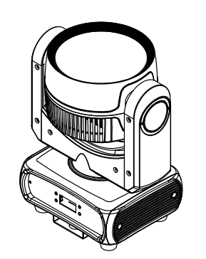
( RGBW )

USER MANUAL



KEEP THIS MANUAL FOR FUTURE NEEDS
Thank you for your patronage. We are confident that our excellent products and service can satisfy you. For your own safety, please read this user manual carefully before installing the device.
In order to install, operate, and maintain the lighting safety correctly. We suggest that the installation and operation should be done by the verified technician and follow the instruction strictly.

A CAUTION! Keep this device away from rain and moisture!

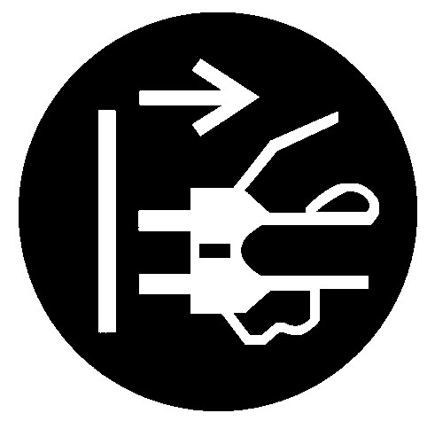
CAUTION!
Unplug mains lead before opening the housing.
Every person involved with the installation, operation and maintenance of this device has to:
-be qualified
-follow carefully the instructions of this manual
1. INTRODUCTION
Thank you for having chosen this professional moving head.
You will see you have acquired a powerful and versatile device.
Unpack the device. Inside the carton box you should find:
- One XLR power cable
- One user manual
- One pcs omega
Please check carefully that there is no damage caused by transportation. Should there be any, please consult your dealer and don’t install this device.
2 Mounting and installation
2.1 Cautions: for added protection mount the fixtures in areas outside walking paths ,seating areas,or in areas were the fixture might be reached by unauthorized personnel.
Before mounting the fixture to any surface ,make sure that the installation area can hold a minimum point load of 10 times the device’s weight.
Fixture installation must always be secured with a secondary safety attachment ,such as an appropriate safety cable.
Never stand directly below the device when mounting ,removing ,or servicing the fixture, from a ceiling,or set on a flat level surface (see illustration below).Be sure this fixture is kept at least 0.5m (1.5ft) away from any flammable (decoration etc.)
Always use and install the supplied safety cable as a safe cable as safety measure to prevent accident damage and /or injury in the event the clamp fails.
2.2 Mounting points:
Overhead mounting requires extensive experience , including among others calculating working load limits, a fine knowledge of the installation material being used ,and periodic safety inspection of all installation material and the fixture. If you lack these qualifications ,
Do not attempt the installation yourself ,improper installation can result in bodily injury.
Be sure to complete all rigging and installation procedures before connecting the main power cord to the appropriate wall outlet.
2.3 Clamp Mounting :
The LED moving head provides a unique mounting bracket assembly that integrates the bottom of the base, the included ‘omega bracket’ (see the following pic)and the safety cable rigging point in one unit.When mounting this fixture to truss be sure to sere to secure an appropriately rated clamp to the included omega bracket using a M10 screw fitted through the center hole of the ‘omega bracket’.As an added safety measure be sure to attached at least one properly rated safety cable to the fixture using on of the safety cable rigging point integrated in the base assembly.
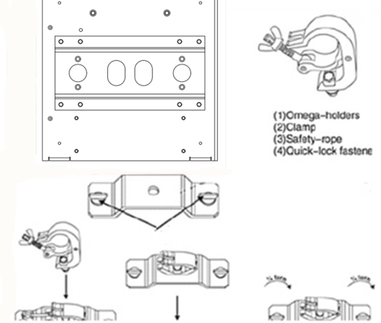
2.4 DMX-512 control connection
Connect the provided XLR cable to the female 3-pin XLR output of your controller and the other side to the male 3-pin XLR input of the moving head. You can chain multiple Moving head together through serial linking. The cable needed should be two core, screened cable with XLR input and output connectors. Please refer to the diagram below.

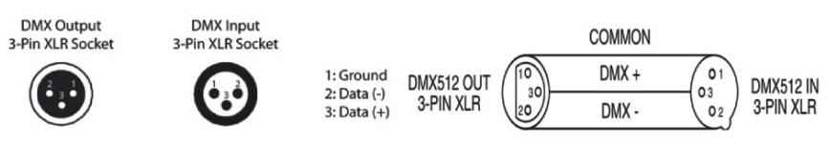

2.4 DMX-512 connection with DMX terminator
For installations where the DMX cable has to run a long distance or is in an electrically noisy environment, such as in a discotheque, it is recommended to use a DMX terminator. This helps in preventing corruption of the digital control signal by electrical noise. The DMX terminator is simply an XLR plug with a 120 resistor connected between pins 2 and 3,which is then plugged into the output XLR socket of the last fixture in the chain. Please see illustrations below.
3 TECHNICAL PARAMETERS
POWER SUPPLIE
Input power:AC100-240V 50/60 Hz
Power consumption :140W
LED Source: 120W RGBW LED
Lamp life : 5000 hours lamp lifespan and low consumption
DMX channel:16 channels
CTO ：2800K-8500K
Color Macro
Beam angle: 25°
Movement :pan 540 degree , tilt 270 degree
Control mode:Auto, Sound, DMX, Master/Slave
Display:LED display
Quick release omega clamps included
PowerCON input/output
3-Pin XLR input/output
Size : 320 x 260x 230 mm
N.W: 3.5kg
G.W:4.5kg
4 :MENU FUNCTION
Menu | Sub menu | info
Addr | A001 ~ A512 | DMX Address 001 ~ 512
CHAN | CH16 | CH16
SOUN | SE00 ~ SE99 | 00 ~ 99
AUTO | S000 ~ S255 | 000 ~ 255
MAnu | r000 ~ r255 | R 0% ~ 100%
MAnu | g000 ~ g255 | G 0% ~ 101%
MAnu | b000 ~ b255 | B 0% ~ 102%
MAnu | U000 ~ U255 | W 0% ~ 103%
MAnu | P000 ~ P255 | Pan 0 ~ 540°
MAnu | T000 ~ T255 | Tilt 0 ~ 240°
TEMP | xxxC
dISP | ONEM | Display Backlight Off in 60s
dISP | PErM | Display Backlight always on
dSPL | NorM | Normal display
dSPL | rEVr | Display reverse
dmOF | bLAC | DMX Blackout
dmOF | HoLd | DMX Hold
rEST | no
rEST | yes
CUrv | LINE
CUrv | SqUA
CUrv | INSq
CUrv | SCur

5: DMX CHANNELS
16 channel definition table
Channel | Function | Dmx Value | Description
1 | Pan | 0 - 255 | Pan
2 | Pan Fine | 0 - 255 | Pan Fine
3 | Tilt | 0 - 255 | Tilt
4 | Tilt Fine | 0 - 255 | Tilt Fine
5 | Motor Speed | 0 - 255 | Speed ( fast to slow)
6 | Dimmer | 0 - 255 | Dimmer 0-100%
7 | Strobe | 0 - 3 | Close
7 | Strobe | 4 - 103 | Rule Strobe, speed changes from slow to fast
7 | Strobe | 104 - 107 | Open
7 | Strobe | 108 - 207 | Pulse Strobe, speed changes from slow to fast
7 | Strobe | 208 - 212 | Open
7 | Strobe | 213 - 225 | Random strobe，Slow speed
7 | Strobe | 226 - 238 | Random strobe，Middle speed
7 | Strobe | 239 - 251 | Random strobe，Fast speed
7 | Strobe | 252 - 255 | Open
8 | R | 0 - 255 | RED Dimmer 0-100%
9 | G | 0 - 255 | GREEN Dimmer 0-100%
10 | B | 0 - 255 | BLUE Dimmer 0-100%
11 | W | 0 - 255 | WHITE Dimmer 0-100%
12 | COLOR TEMP | 0 | EMPTY
12 | COLOR TEMP | 1 - 255 | 8500K - 2800K
13 | COLOR MACRO | 0 - 9 | EMPTY
13 | COLOR MACRO | 10 - 255 | COLOR MACRO
14 | INTER-PROGRAM | 0 | EMPTY
14 | INTER-PROGRAM | 1 -- 25 | Gradient effect
14 | INTER-PROGRAM | 26 - 51 | Chasing effect
14 | INTER-PROGRAM | 52 - 77 | Rainbow Effect
14 | INTER-PROGRAM | 78 - 103 | Gradient effect 1
14 | INTER-PROGRAM | 104 - 129 | Gradient effect 2
14 | INTER-PROGRAM | 130 - 155 | Gradient effect 3
14 | INTER-PROGRAM | 156 - 181 | Gradient effect 4
14 | INTER-PROGRAM | 182 - 207 | Gradient effect 5
14 | INTER-PROGRAM | 208 - 233 | Gradient effect 6
14 | INTER-PROGRAM | 234 - 255 | Gradient effect 7
15 | Effect Speed | 0 - 255 | Effect Speed (Slow to fast)
16 | Reset | 0 - 199 | Empty
16 | Reset | 200 - 205 | reset ( after 5 second )
16 | Reset | 206 - 255 | empty

